THERMAL ENERGY PROBLEMS

Thermal energy (Eh) is an example of energy, as it is due to the motion of , with motion being the key. Thermal energy results in an object or a system having a that can be measured. Thermal energy can be from one object or system to another in the form of . Sometimes thermal energy is defined as the total internal energy of all the particles in a body. This would include the translational ( ) kinetic energy that could be detected by a , as well as all the energies contained in the and of particles that be detected. This is why a mass can energy and increase its temperature (for example: when melting ice into liquid water, it will take in energy, but change temperature until the liquid has formed, then the temperature will start to rise.)

To calculate the energy, Eh, of an object, use the following formula:

Where:
- Mass (m) is measured in ______________ (kg)
- Specific heat capacity (C) is measured in joules per kilogram per kelvin (________________)
- Temperature (T) measured in ____________ (K)
- E_{h} is measured in __________ (J)
Note: we use the subscript “h” (from “heat”) for thermal energy because “t” will be used later for “total” energy. It’s not quite right, but will do for now.

It is rare to need to calculate the total thermal energy of an object. Most often we are interested in the increase or decrease of thermal energy. Heat is defined as the change in thermal energy (ΔEh). Heating refers to an increase in thermal energy and cooling refers to a decrease in thermal energy.

To calculate the in thermal energy (or heat) ΔEh of an object, use the following formula:

Equation:

The size of one kelvin and the size of one degree Celsius is the on a thermometer, therefore the change in temperature (ΔT) can be measured in either kelvin degrees Celsius and is defined as the between the final temperature Tf and the initial temperature Ti.
Equation:

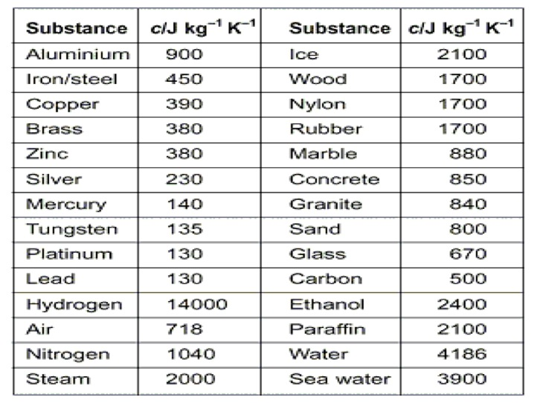
The specific heat capacity can then be in (J/kg·K) or in (J/kg·°C). This is a specific property unique to every material. Here is a list of common specific heat capacities:
Note: To earn full marks when solving science word problems, you must Show your work. Don’t forget to convert units into the proper base units before calculating.

Example Problem:

1. How much energy would be required to raise the temperature of a gold ring from 31.0°C to 1 064°C (the melting point of gold)? Let’s assume the ring has a mass of 5.00 g and the specific heat capacity of gold is 129 J/kg°C.

Solution:
For all these problems we will need the specific heat capacity of each substance. Sometimes it will be given to you, but if not, look it up.

Practice Questions: (Your solutions should be organized similar to the example problem. Show all your steps please)

An online specific heat capacity table is available here: goo.gl/65gAMu

1. How much heat energy is required to warm 3.5 kg of water from 16°C to 96°C?

2. What is the mass of a lead block if it takes 67 kJ to raise the temperature by 100.0°C?

3. If a pile of snow (c=2090J/kg/k) with a mass of 525 kg loses 7.40 MJ of thermal energy during the night, how much will the temperature of the snow drop?

4. What is the final temperature of 0.63 kg of water that releases 2290 joules of thermal energy? The water had an initial temperature of 48.2°C.

5. What is the total thermal energy in a human body? Let’s assume some things: The average specific heat capacity of a human body is approximately 3500 J/(kg·K) at normal conditions. The average human has a mass of 72.0 kg. Body temperature is normally
37.0 °C.

6. In his part time job as a blacksmith, Nathan was quenching (cooling) a 350 g iron horseshoe from 470.0 °C to 30.0 °C by plunging the horseshoe into a bucket of cold water. How much thermal energy was lost by the horseshoe?

7. If the bucket of water that Nathan (from the last question) contained 14.0 kg of water that had an initial temperature of 25.0 °C, how much would the water temperature increase when cooling the horseshoe? The energy lost by horseshoe is the energy gained by the water…

8. A standard gold bar (c=129 J/kg°C), also referred to as gold ingot or gold bullion has a mass of 12.4 kg (what is known as 400 troy ounces). If the melting point of gold is 1063 °C, how much energy would be needed to bring one standard gold bar from room temperature of 20.0 °C to its melting point?

9. If two bars of copper and gold have equal masses of 250 g, and have equal starting temperatures, how much will their final temperatures differ by if 6.5 kJ of thermal energy is added to each of the bars?

10. Milan started a fire in her fireplace which has a granite surround with a mass of 240 kg. If the granite started at 18.0 °C, how much energy was needed to raise its temperature to
32.0 °C?

