THERMAL ENERGY PROBLEMS

Thermal energy (Eh) is an example of kinetic energy, as it is due to the motion of particles, with motion being the key. Thermal energy results in an object or a system having a temperature that can be measured. Thermal energy can be transferred from one object or system to another in
the form of heat. Sometimes thermal energy is defined as the total internal energy of all the particles in a body. This would include the translational (sideways) kinetic energy that could be detected by a thermometer, as well as all the energies contained in the vibrations and rotations of particles that cannot be detected. This is why a mass can absorb energy and not increase its temperature (for example: when melting ice into liquid water, it will take in energy, but not change temperature until the liquid has formed, then the temperature will start to rise.)

To calculate the total thermal energy, Eh, of an object, use the following formula:

Eh = mCT

Where:

Mass (m) is measured in kilograms (kg)
Specific heat capacity (C) is measured in joules per kilogram per kelvin (J/kg·K) Temperature (T) measured in kelvin (K)
Eh is measured in joules (J) [note, we use the subscript “h” (from “heat”) for thermal energy because “t” will be used later for
“total” energy. It’s not quite right, but will do for now.]

It is rare to need to calculate the total thermal energy of an object. Most often we are interested in the increase or decrease of thermal energy. Heat is defined as the change in thermal energy
(ΔEh). Heating refers to an increase in thermal energy and cooling refers to a decrease in thermal energy.

To calculate the change in thermal energy (or heat) ΔEh of an object, use the following formula:

ΔEh = mCΔT

The size of one kelvin and the size of one degree Celsius is the same on a thermometer, therefore the change in temperature (ΔT) can be measured in either kelvin or degrees Celsius
and is defined as the difference between the final temperature Tf and the initial temperature Ti
ΔT = Tf - Ti

The specific heat capacity can then be in (J/kg·K) or in (J/kg·°C). This is a specific property unique to every material. Here is a list of common specific heat capacities:

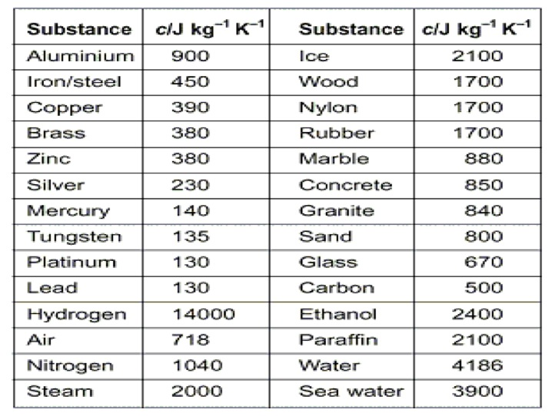

Note: To earn full marks when solving science word problems, you must Show your work. Don’t forget to convert units into the proper base units before calculating.

Example Problems:

1. How much energy would be required to raise the temperature of a gold ring from
31.0°C to 1 064°C (the melting point of gold)? Let’s assume the ring has a mass of 5.00 g and the specific heat capacity of gold is 129 J/kg°C.

Solution:
For all these problems we will need the specific heat capacity of each substance. Sometimes it will be given to you, but if not, look it up. C for gold is 129 J/kg°C
m = 5.00 g = 0.00500 kg
C = 129 J/kg°C Ti = 31.0°C
Tf = 1 064°C

ΔEh = mCΔT
= (0.00500)(129)(1 064 - 31.0)
= 666.285
= 666 J

Practice Questions: (Your solutions should be organized similar to the example problem. Show all your steps please)

An online specific heat capacity table is available here: goo.gl/65gAMu

1. How much heat energy is required to warm 3.5 kg of water from 16°C to 96°C?

2. What is the mass of a lead block if it takes 67 kJ to raise the temperature by 100.0°C?

3. If a pile of snow (c=2090J/kg/k) with a mass of 525 kg loses 7.40 MJ of thermal energy during the night, how much will the temperature of the snow drop?

4. What is the final temperature of 0.63 kg of water that releases 2290 joules of thermal energy? The water had an initial temperature of 48.2°C.

5. What is the total thermal energy in a human body? Let’s assume some things: The average specific heat capacity of a human body is approximately 3500 J/(kg·K) at normal conditions. The average human has a mass of 72.0 kg. Body temperature is normally
37.0 °C.

6. In his part time job as a blacksmith, Nathan was quenching (cooling) a 350 g iron horseshoe from 470.0 °C to 30.0 °C by plunging the horseshoe into a bucket of cold water. How much thermal energy was lost by the horseshoe?

7. If the bucket of water that Nathan (from the last question) contained 14.0 kg of water that had an initial temperature of 25.0 °C, how much would the water temperature increase when cooling the horseshoe? The energy lost by horseshoe is the energy gained by the water…

8. A standard gold bar (c=129 J/kg°C), also referred to as gold ingot or gold bullion has a mass of 12.4 kg (what is known as 400 troy ounces). If the melting point of gold is 1063 °C, how much energy would be needed to bring one standard gold bar from room temperature of 20.0 °C to its melting point?

9. If two bars of copper and gold have equal masses of 250 g, and have equal starting temperatures, how much will their final temperatures differ by if 6.5 kJ of thermal energy is added to each of the bars?

10. Milan started a fire in her fireplace which has a granite surround with a mass of 240 kg. If the granite started at 18.0 °C, how much energy was needed to raise its temperature to
32.0 °C?

