Science 10 Energy Unit Name:
Block:

CONSERVATION OF ENERGY PROBLEMS

The law of conservation of energy is a law of science that states that energy cannot be created or destroyed, but only changed from one form into another or transferred from one object to another.

This means that the total energy in a closed system must remain constant, or the total energy
(Et) at any time, must equal the total energy at any other point in time (Et′).

Et = Et′

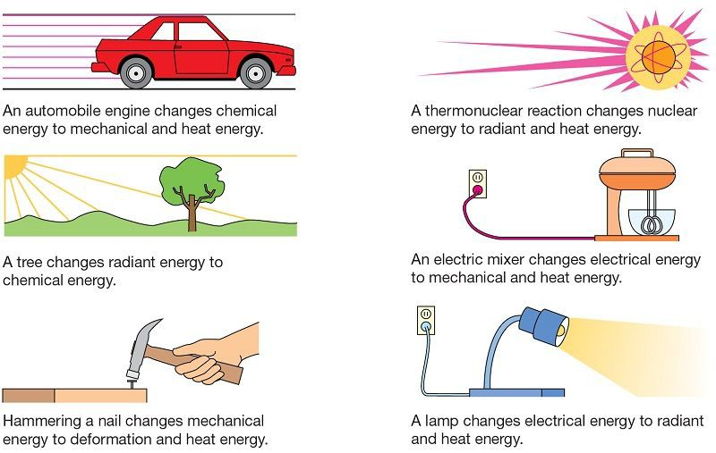

Note that in a nuclear reaction, mass may be lost and converted to energy according to Einstein's formula E = mc2 where E is energy in joules, m is the mass
in kilograms, and c is the speed of light in m/s.

Example Problem:

A ball is thrown upward and reaches a height of 21.0 m above the point of release. What was the velocity of the ball just after being released?

Known Values:
m = ? (sometimes this is not needed, stay tuned…)
h = 21.0 m
g = 9.80 N/kg (on Earth)

Formula: | Et = Et′  Ek = Ep′ | (total energy before = total energy after)  (only kinetic E at bottom, only potential E at the top)
 | ½mv2 = mgh | (notice there is an “m” on either side,
 |  | so divide both sides by m!)
 | ½ v2 = gh | (now multiply both sides by 2)
 | v2 = 2gh | (now take the square root of both sides)
 | v = √2gh
 | v = √2(9.80)(21.0)  v = 20.2879 | (substitute in the data values)  (calculate)
 | v = 20.3 m/s | (round off and add the units)

Practice Questions: (Your solutions should be organized similar to the example problem. Show all your steps please. Round to 3 digits)

1. A student is dropped. If they reach the floor at a speed of 3.20 m/s, from what height did they fall? (no students were harmed in the making of this problem.)

2. A heavy object is dropped from a vertical height of 8.00 m. What is its speed when it hits the ground?

3. A bowling ball is dropped from the top of a building. If it hits the ground with a speed of 37.0 m/s, how tall was the building?

4. A safe is hurled down from the top of a 135 m tall building at a speed of 11.0 m/s. What is its velocity as it hits the ground?

5. A box slides down a frictionless ramp. If it starts at rest, what is its speed at the bottom? (assume the box started at the very top of the ramp)
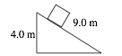

6. A pendulum is dropped from the position shown, 0.250 m above its equilibrium position.
What is the speed of the pendulum bob as it passes through its equilibrium position?
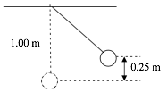

7. A box slides down a frictionless incline as shown. If the box starts from rest, what is its speed at the bottom? (assume the box started at the very top of the ramp)
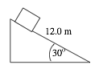

8. A roller coaster car starts from rest at point A. What is its speed at point C if the track is frictionless?
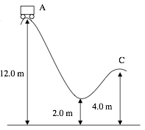

9. The roller coaster shown above has a mass of 525 kg and is travelling at 2.10 m/s at point A, what is the speed at the lowest point?

10. An 80.0 kg student running at 3.50 m/s grabs a rope that is hanging vertically. How high will the student swing?


