CONSERVATION OF ENERGY PROBLEMS

The law of conservation of energy is a law of science that states that energy cannot be or , but only changed from one into or transferred from one to another.

This means that the total energy in a system must remain , or the total energy
(Et) at any time, must the total energy at any other point in time (Et′).

Et = Et′

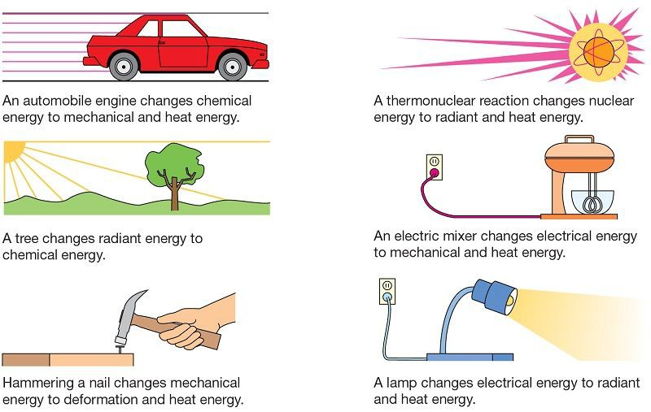

Note that in a nuclear reaction, mass may be lost and converted to energy according to Einstein's formula E = mc2 where E is energy in joules, m is the mass
in kilograms, and c is the speed of light in m/s.

Example Problem:

A ball is thrown upward and reaches a height of 21.0 m above the point of release. What was the velocity of the ball just after being released?

Practice Questions: (Your solutions should be organized similar to the example problem. Show all your steps please. Round to 3 digits)

1. A student is dropped. If they reach the floor at a speed of 3.20 m/s, from what height did they fall? (no students were harmed in the making of this problem.)

2. A heavy object is dropped from a vertical height of 8.00 m. What is its speed when it hits the ground?

3. A bowling ball is dropped from the top of a building. If it hits the ground with a speed of 37.0 m/s, how tall was the building?

4. A safe is hurled down from the top of a 135 m tall building at a speed of 11.0 m/s. What is its velocity as it hits the ground?

5. A box slides down a frictionless ramp. If it starts at rest, what is its speed at the bottom? (assume the box started at the very top of the ramp)
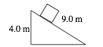

6. A pendulum is dropped from the position shown, 0.250 m above its equilibrium position.
What is the speed of the pendulum bob as it passes through its equilibrium position?
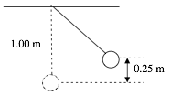

7. A box slides down a frictionless incline as shown. If the box starts from rest, what is its speed at the bottom? (assume the box started at the very top of the ramp)
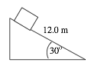

8. A roller coaster car starts from rest at point A. What is its speed at point C if the track is frictionless?
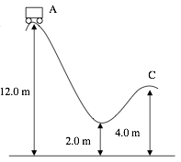

9. The roller coaster shown above has a mass of 525 kg and is travelling at 2.10 m/s at point A, and is later travelling at 12.7 m/s at the lowest point. How much energy was lost to heat on the trip down?

10. An 80.0 kg student running at 3.50 m/s grabs a rope that is hanging vertically. How high will the student swing?


