Genetics

Lesson 9: Mutations

Learning Outcomes
- I can define what a mutation is.
- I can explain when a mutation is beneficial, neutral or harmful.

Species:
- a group of individuals that can ____________________________________________
_____________________________________________________________________
- share common genes but have slight ______________________________________ _____________________________________________________________________

Mutations:
- a permanent change in the DNA sequence of an individual
- may occur in:
- somatic cells – _____________________________________________________
- germ line cells – ____________________________________________________
** may result in change in all of an individual’s offspring
- only ____________________ mutations can result in a change to a species as they are the source of new alleles
- mutations can be:
- beneficial – ________________________________________________________
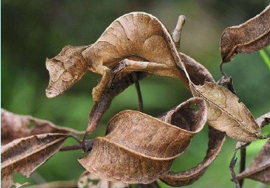
harmful – _________________________________________________________
_________________________________________________________

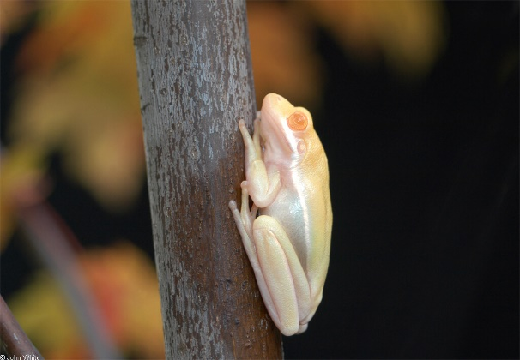

neutral – _________________________________________________________
_________________________________________________________

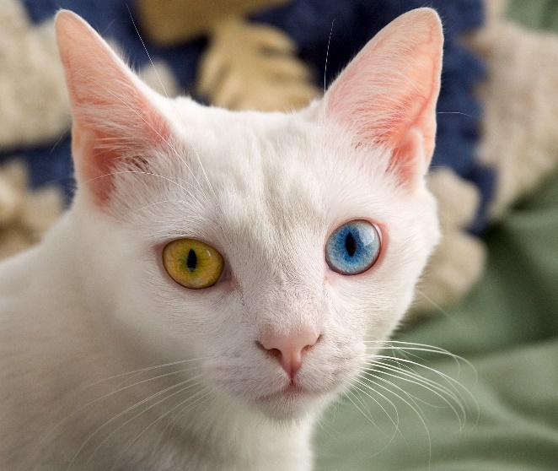
Effects of Mutations:
- remember that genes in DNA code for the proteins that carry out many of the functions in your body – structural proteins, hormones, antibodies, etc.
- when a mutation changes the sequence of a gene (DNA sequence), it can result in:
- Point Mutation (or Substitution)
- _______________________________________________________________
can result in:
Silent Mutation – _______________________________________________
____________________________________________________________
 | Original Strand | Mutated Strand
DNA | TAC GCG AAT AGT ACT | TAC GCG AAT AGG ACT
mRNA
Amino Acid

Missense Mutation – ____________________________________________
______________________________________________________________
 | Original Strand | Mutated Strand
DNA | TAC GCG AAT AGT ACT | TAC GCG AAT GGT ACT
mRNA
Amino Acid

Nonsense Mutation – ___________________________________________
____________________________________________________________
 | Original Strand | Mutated Strand
DNA | TAC GCG AAT AGT ACT | TAC GCG ATT AGT ACT
mRNA
Amino Acid

- Frameshift Mutation
- a change in the _________ ____________ of RNA caused by adding or removing bases
Results in:

Deletion Mutation – __________________________________________
____________________________________________________________

 | Original Strand | Mutated Strand
DNA | TAC GTG CGA AAT GAT | TAC GGC GAA ATG AT
mRNA | AUG CAC GCU UUA CUA
Amino Acid | met – his – ala – leu – leu

Insertion Mutation – __________________________________________
____________________________________________________________

 | Original Strand | Mutated Strand
DNA | TAC GTG CGA AAT GAT | TAC GTA GCG AAA TGA T
mRNA | AUG CAC GCU UUA CUA
Amino Acid | met – his – ala – leu – leu

- frameshift mutations usually result in more harmful effects _________________
__________________________________________________________________

Causes of Mutation:
- can occur spontaneously during _______ _____________________
- may be caused by external influences _____________ are substances or events that can cause a change in DNA
two main categories of mutagens:
- Physical Mutagens
- _______________________________________________________________
- examples: UV light, X-ray radiation

- Chemical Mutagens
- _______________________________________________________________
_______________________________________________________________
- examples: nitrites, gasoline fumes

Carcinogens:
- physical or chemical mutagens that _____________________________________
__________________________________________________________________

