Genetics

Lesson 9: Mutations

Learning Outcomes
- I can define what a mutation is.
- I can explain when a mutation is beneficial, neutral or harmful.

Species
- a group of individuals that can interbreed and produce fertile offspring
- share a common DNA base that has slight variations in some of the DNA sequences (alleles)

Mutations
- a permanent change in the DNA sequence of an individual
- may occur in:
- somatic cells – normal body cells that may result in a change in that individual
- germ line cells – gamete (sperm & egg) producing cells that may result in a
change in all of an individual’s offspring
- only germ line mutations can result in a change to a species as they are the source of new alleles
- mutations can be:
- beneficial – aids in survival (ex: better camouflage)
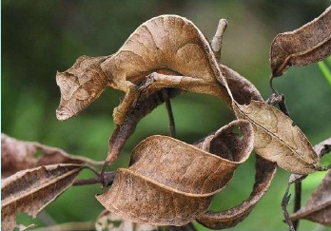
- harmful – results in death or decreased survival ability (ex: third hind leg on
frogs)
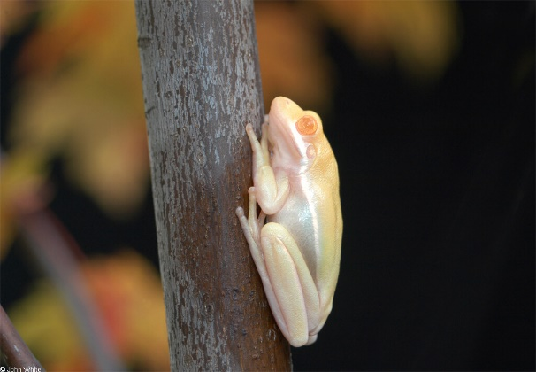

- neutral – changes in the DNA sequence does not change the organisms (ex: in
non-reading portion of DNA) or changes that do not influence survival rates (ex: dichromatic eyes)
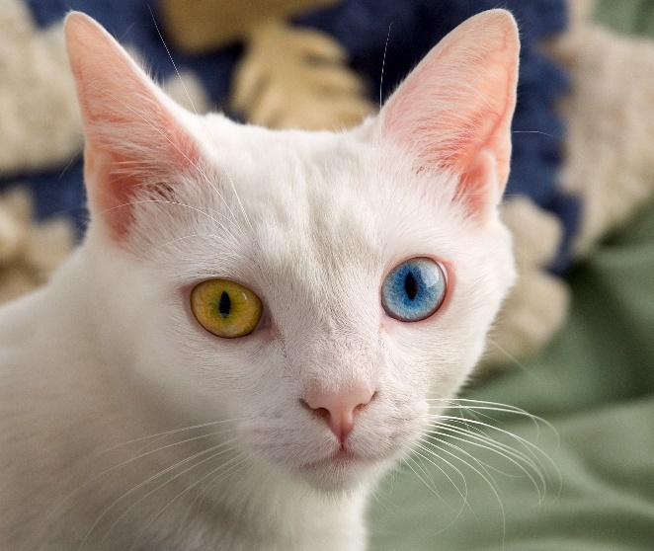

Effects of Mutations
- remember that genes in DNA code for the proteins that carry out many of the functions in your body – structural proteins, hormones, antibodies, etc.
- when a mutation changes the sequence of a gene (DNA sequence), it can result in:
- Point Mutation (or Substitution)
- occurs when one base is changed for a different base
- can result in:
- silent mutation – order of amino acids after translation does not change
 | Original Strand | Mutated Strand
DNA | TAC GCG AAT AGT ACT | TAC GCG AAT AGG ACT
mRNA | AUG CGC UUA UCA UGA | AUG CGC UUA UCC UGA
Amino Acid | met – arg – leu – ser – stop | met – arg – leu – ser – val

- missense mutation – single nucleotide change results in different amino acid
 | Original Strand | Mutated Strand
DNA | TAC GCG AAT AGT ACT | TAC GCG AAT GGT ACT
mRNA | AUG CGC UUA UCA UGA | AUG CGC UUA CCA UGA
Amino Acid | met – arg – leu – ser – stop | met – arg – leu – pro – stop

- nonsense mutation – mRNA codes for an early stop codon
 | Original Strand | Mutated Strand
DNA | TAC GCG AAT AGT ACT | TAC GCG ATT AGT ACT
mRNA | AUG CGC UUA UCA UGA | AUG CGC UAA UAA UGA
Amino Acid | met – arg – leu – ser – stop | met – arg – stop
- Frameshift Mutation
- a change in the reading frame of RNA caused by adding or removing bases
- results in:
- Deletion Mutation – loss of a base or bases causing a shortening of the amino acids sequence
 | Original Strand | Mutated Strand
DNA | TAC GTG CGA AAT GAT | TAC GGC GAA ATG AT
mRNA | AUG CAC GCU UUA CUA | AUG CCG CUU UAC UA
Amino Acid | met – his – ala – leu – leu | met – pro – leu – tyr

- Insertion Mutation – addition of a base or bases causing a lengthening of the amino acid sequence
 | Original Strand | Mutated Strand
DNA | TAC GTG CGA AAT GAT | TAC GTA GCG AAA TGA T
mRNA | AUG CAC GCU UUA CUA | AUG CAU CGC UUU ACU A
Amino Acid | met – his – ala – leu – leu | met – his – arg – phe – thr

- frameshift mutations usually result in more harmful effects since there is often a greater change in the amino acid sequence

Causes of Mutation
- can occur spontaneously during cell division
- may be caused by external influences mutagens are substances or events that can cause a change in DNA
- two main categories of mutagens
- Physical Mutagens
- cause a physical change in the sequence of DNA in an organism
- examples: UV light, X-ray radiation

- Chemical Mutagens
- caused by chemicals that enter a cell and chemically react with DNA
- examples: nitrites, gasoline fumes

- Carcinogens
- physical or chemical mutagens that result in the formation of cancer

https://www.youtube.com/watch?v=1v55yg0RfoY
Sickle cell anemia is an example of a missense mutation
https://www.ted.com/talks/amber_m_yates_how_this_disease_changes_the_shape_of_your_cells/transcript?language=en#t-240861

