Genetics

Genetics and Diversity

Learning Outcomes:
- I can describe how genetic diversity accounts for differences between individuals, species and ecosystems.

Biodiversity
- ______________________________________________________________________________________________________________________________________________________
- ______________________________________________________________________________________________________________________________________________________
- _________________________________________________________________________________________________________________________________________________________________________________________________________________________________

- Genetic Diversity
- ________________________________________________________________________________________________________________________________________________
- ________________________________________________________________________
- __________________________________________________________________________________________________________________________________________
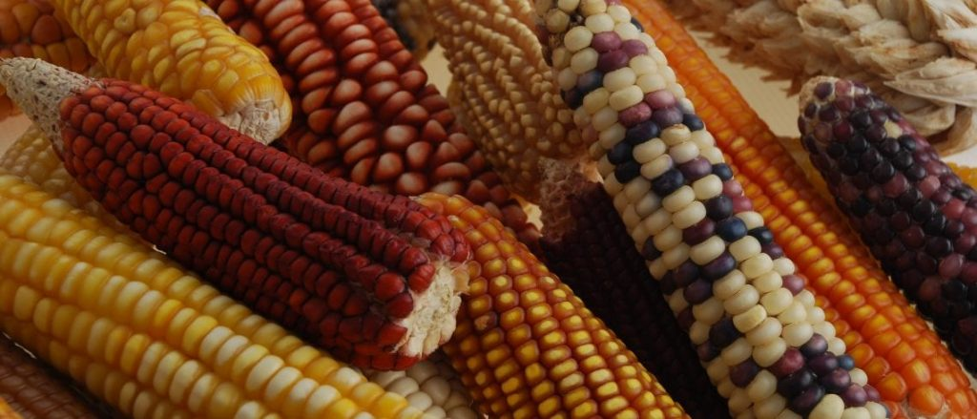
- Species Diversity
- ________________________________________________________________________
- _____________________________________________________________________
- _____________________________________________________________________
- ________________________________________________________________________
- ________________________________________________________________________
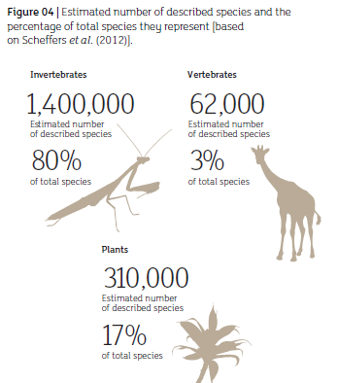
- Ecosystem Diversity
- ________________________________________________________________________
- ________________________________________________________________________
- ________________________________________________________________________



