Genetics

DNA Replication & Protein Formation

Learning Outcomes:
- I can describe the basic process of DNA replication.
- I can describe how a DNA gene sequence is used to make a protein.

DNA Replication
- prior to mitosis, all of the genetic material in a cell needs to be duplicated
- called DNA replication
- H-bonds between 2 strands of DNA of a chromosome are “unzipped” by the enzyme DNA helicase
- new nucleotides are attached to each strand of DNA following complimentary base pairing by the enzyme DNA polymerase
- forms 2 identical double-stranded copies
- called semi-conservative replication because one strand in each new chromosome is conserved from the original chromosome

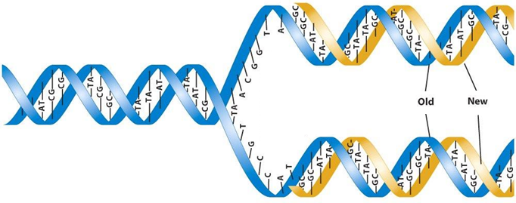

Protein Formation
- gene sequence code the formation of a functioning protein (enzyme, structural protein, hormone, etc.)
- two-step process
- Transcription
- since DNA is too large to fit through a pore in the nuclear membrane, it needs to create a smaller messenger
- a gene sequence unwinds and one side of the chromosome is copied as a messenger RNA (mRNA)
DNA | RNA
- double stranded  - bases are Adenine (A) – Thymine (T) and Cytosine (C) – Guanine (G)  - sugar is deoxyribose | - single strand  - bases are Adenine (A) – Uracil (U) and Cytosine (C) – Guanine (G)  - sugar is ribose

example:
DNA T A C G C G A A T T G T C A C T A G A C C A C T
mRNA A U G C G C U U A A C A G U G A U C U G G U G A

- Translation
- mRNA moves into the cytoplasm and binds with a ribosomal RNA (rRNA)
- rRNA translates the instructions in the mRNA into a chain of amino acids
- mRNA is read in sets of 3 bases called a codon that codes for a specific amino acid
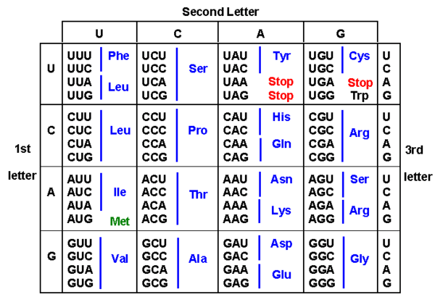

- example:
RNA AUG CGC UUA ACA GUG AUC UGG UGA
Amino Acid met – arg – leu – thr – val – ile – trp – stop
- chain of amino acids is then folded up into its functional shape

