Genetics

DNA Replication & Protein Formation

Learning Outcomes:
- I can describe the basic process of DNA replication.
- I can describe how a DNA gene sequence is used to make a protein.

DNA Replication
- ___________________________________________________________________________
- called DNA replication
- ________________________________________________________________________________________________________________________________________________
- ________________________________________________________________________________________________________________________________________________
- _____________________________________________________________________
- _______________________________________________________________________________________________________________________________________________________________________________________________________________

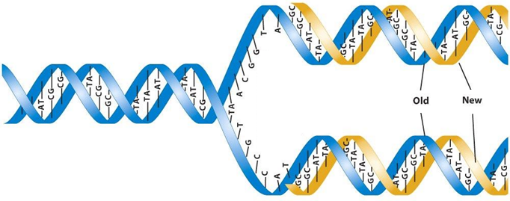

Protein Formation
- ___________________________________________________________________________
- Transcription
- ________________________________________________________________________________________________________________________________________________
- ________________________________________________________________________________________________________________________________________________

DNA RNA

- example:
DNA T A C G C G A A T T G T C A C T A G A C C A C T
RNA

- Translation
- ________________________________________________________________________
- ________________________________________________________________________________________________________________________________________________
- ________________________________________________________________________________________________________________________________________________
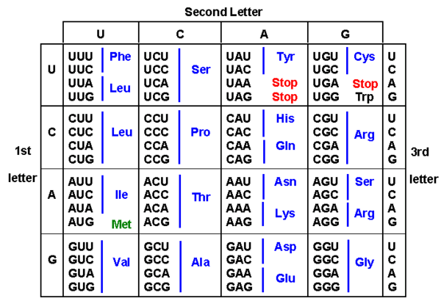

- example:
RNA AUG CGC UUA ACA GUG AUC UGG UGA
Amino Acid
- ________________________________________________________________________

