Genetics Lesson 2 Worksheet

Label the diagram using the words in bold

base chromatid chromatin chromosome DNA gene histone

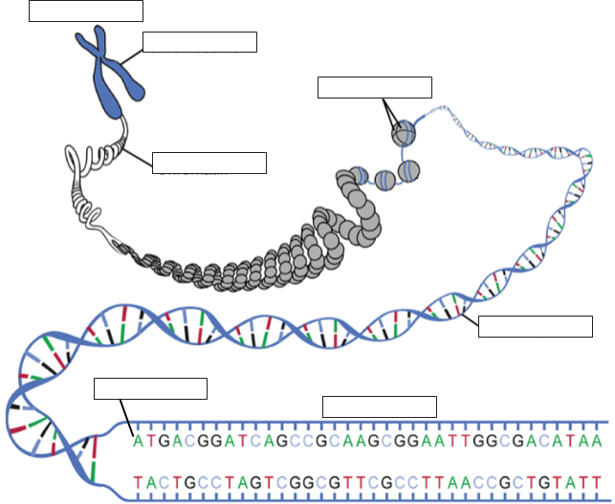

Part 2. Short answers
- What is the difference between chromatin and a chromosome?

- When are chromosomes visible using a microscope?

- Why do some chromosomes look like a letter X and some do not?

- What is a histone and what is its function?

- What is a gene and what is its function?

- What is an allele? Give an example.

- Where are chromosomes located in a cell?

- What is a trait?

- What is a karyotype?

- Why are X and Y chromosomes referred to as sex chromosomes?

