Genetics

Lesson 2: Chromosomes

Learning Outcomes:
- I can explain how DNA, chromatin and chromosomes are linked.
- I can explain the difference between genes, traits and alleles.
- I can explain what a karyotype is.

Chromatin and Chromosomes
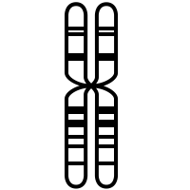

Genes:
- Gene: – ____________________________________________________________________
- Alleles – ____________________________________________________________________
___________________________________________________________________________

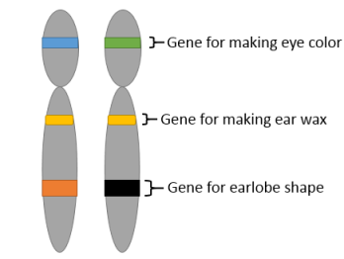
Chromosomes:
- Autosomal or Mendelian Traits
- _____________________________________________________________________
- _____________________________________________________________________

- Multiple Allele Traits
- _____________________________________________________________________
- _____________________________________________________________________

- Polygenic Traits
- __________________________________________________________________________________________________________________________________________
- _____________________________________________________________________

- Sex-Linked Traits
- _____________________________________________________________________
- _____________________________________________________________________

Karyotypes
- ___________________________________________________________________________
- ___________________________________________________________________________



