Genetics

Lesson 2: Chromosomes

Learning Outcomes:
- I can explain how DNA, chromatin and chromosomes are linked.
- I can explain the difference between genes, traits and alleles.
- I can explain what a karyotype is.

Chromatin and Chromosomes

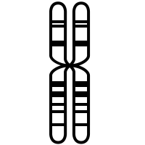

Genes
- a gene is a sequence of DNA that codes for a specific trait
- alleles – variations in a gene that results in differences in individuals
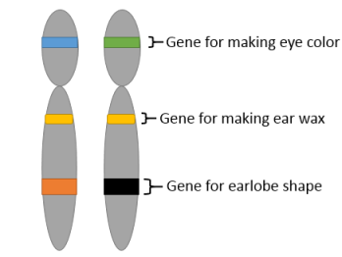

What is a chromosome?
https://www.youtube.com/watch?v=IePMXxQ-KWY

- Autosomal or Mendelian Traits
- one gene sequence traits with only 2 allele variations
- ex: hair line, hitch-hiker’s thumb, earlobes

- Multiple Allele Traits
- one gene sequence traits with more than 2 allele variations
- ex: blood type

- Polygenic Traits
- traits controlled by multiple genes, each with 2 or more allele variations
- ex: eye colour, hair colour, height

- Sex-Linked Traits
- traits affected by the presence or absence of the Y chromosome
- ex: colour blindness, baldness

Karyotypes
- refers to the number and appearance of paired chromosomes from a eukaryotic cell (i.e., a cell with a nucleus)
- often shown as a photograph

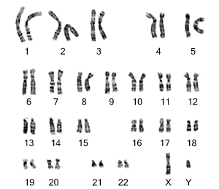

Homework
Genetics worksheet Lesson 2
Chromosomes and Karyotypes Activity

