Genetics

Lesson 10: Natural Selection

Learning Outcomes
- I can define natural selection.
- I can explain when a mutation can cause a change in a population.
- I can explain how selection pressures can lead to a species extinction.

Natural Selection
- within a population, individuals ___________________________________________
- examples: _________________________________________________________
- some traits in a population may be more _________________ to the survival of those individuals that exhibit that trait
- example: _______________________
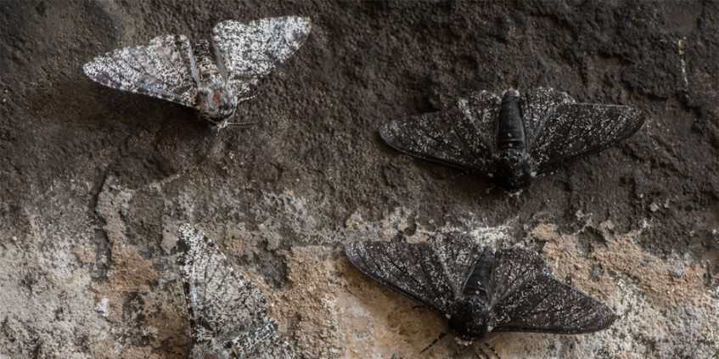
- in these cases, the _____________________________________________________
_____________________________________________________________________
- individuals with the ____________________ (allele) are more likely to survive and reproduce so the _________________ of their trait (allele) in the population ______________
- individuals with a different allele are less likely to survive and so _____________ of their trait (allele) in the population ______________
- ________________ may introduce new alleles to a population that may increase or decrease _____________ in that environment.
- natural selection is ________________.
- traits that are favoured in one population may not be beneficial in a different population of the same species because of ______________________________.

Speciation
- __________________________________________________________________________________________________________________________________________
- _____________________________________________________________________
- example: ______________
- over thousands of years, horses have slowly gotten _____________ and their ____________________ shape has changed
- caused by natural selection acting on the _______________________________
- ____________________________________________________________________

Adaptive Radiation
- _______________________________________________________________________________________________________________________________________________________________________________________________________________
Forest Population | Mountain Population
- if the two populations change enough compared to each other, they can stop being able to produce ________________ together
- example: __________________________________
- finch population blown to Galapagos Islands (15 islands) from _______________
- different ______________________ on the different islands
- finches on different islands gradually evolved different ____________________ to match the food types

Extinction & Selective Pressure
- __________________________________________________________________________________________________________________________________________
- major catastrophic events can lead to dramatic changes in the __________________
- example: __________________caused large amounts of dust and soot to be thrown into the atmosphere ________________________________________ change in global ______________ caused the extinction of the ____________
- fossil records indicate that there have been______________________________ (75% or greater loss of species)

