Genetics

Lesson 10: Natural Selection

Learning Outcomes
- I can define natural selection.
- I can explain when a mutation can cause a change in a population.
- I can explain how selection pressures can lead to a species extinction.

Natural Selection
- within a population, individuals exhibit variations of different traits
- hair colour, leg length, hearing
- some traits in a population may be more beneficial to the survival of those individuals that exhibit that trait
- example: peppered moth
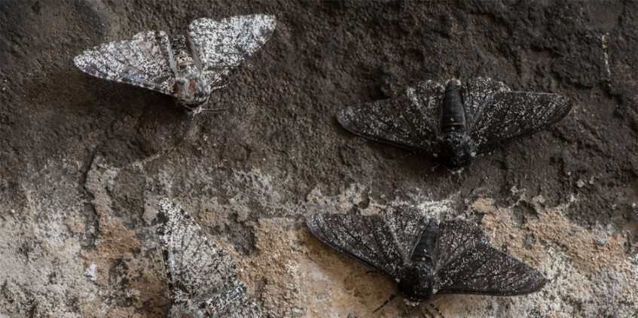
- in these cases, the environment exerts a selective pressure on that population
- individuals with the favoured trait (allele) are more likely to survive and reproduce so the frequency of their trait (allele) in the population increases
- individuals with a different allele are less likely to survive and so frequency of their trait (allele) in the population decreases
- mutations may introduce new alleles to a population that may increase or decrease fitness in that environment.
- natural selection is situational
- traits that are favoured in one population may not be beneficial in a different population of the same species because of differences in the environments

Speciation
- the formation of a new species from an existing species
- can occur with a single population
- example: horses
- over thousands of years, horses have slowly gotten larger and their body shape has changed
- caused by natural selection acting on the species as a whole
- one species becoming another species
Adaptive Radiation
- when two or more different populations of the same species live in different types of habitats, the environmental pressures acting on them might not be the same and the two populations would start to change independent of each other
Forest Population | Mountain Population
- climb trees  - camouflage in trees  - shorter sight-lines | - climb over rocks  - camouflage in rocks  - farther sight-lines
- if the two populations change enough compared to each other, they can stop being able to produce offspring together
- example: Galapagos finches
- finch population blown to Galapagos Islands (15 islands) from South America
- different food types on the different islands
- finches on different islands gradually evolved different beak sizes to match the food types

Extinction & Selective Pressure
- selective pressures caused by environmental changes can also cause a species to become extinct
- major catastrophic events can lead to dramatic changes in the environment
- example: asteroid impact caused large amounts of dust and soot to be thrown into the atmosphere blocked out solar energy change in global temperature caused the extinction of the dinosaurs
- fossil records indicate that there have been 5 mass extinction events (75% or greater loss of species)

https://www.youtube.com/watch?v=sVVldxxbWig
Peppered moth video

