Genetics

Lesson 1: DNA

Learning Outcomes:
- I can describe the basic structure and function of DNA.

Structure
- first observed in 1869 by the German biochemist Frederich Miescher
- did not realize the importance of the molecule he had found
- discovery of the structure of structure of DNA:
- Maurice Wilkins (1950) – ___________________________________________________
________________________________________________________________________
- Rosalind Franklin (1952) - ___________________________________________________
________________________________________________________________________
- James Watson & Francis Crick (1953) – ________________________________________
________________________________________________________________________
- Looks like a twisted ladder __________________________________________________
- “Ladder sides” are made of _________________________________________________
- “Steps/Rungs” are made of _________________________________________________
- ________________________________________________________________________

- ___________________________________________________________________________
____________ (__) ----- ____________ (__) | called ________________________________
____________ (__) ----- ____________ (__) | called ________________________________
Example: Strand 1 A T A A C G T C A
Strand 2

- Human DNA is composed of around 3 billion nucleotides on 46 chromosomes
- DNA stands for: ______________________________________________________________
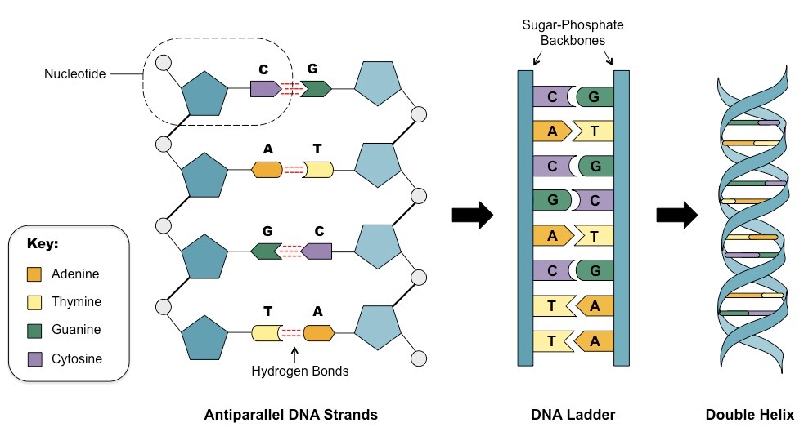

DNA Function
- ___________________________________________________________________________



 

