Genetics

Lesson 1: DNA

Learning Outcomes:
- I can describe the basic structure and function of DNA.
Video: What is DNA?
https://www.youtube.com/watch?v=6rv5Z8EBXwY

Structure
- first observed in 1869 by the German biochemist Frederich Miescher
- did not realize the importance of the molecule he had found
- discovery of the structure of structure of DNA:
- Maurice Wilkins (1950) – first used X-ray diffraction on ram sperm to try to discover the shape of DNA
- Rosalind Franklin (1952) – extended the work of Wilkins to produce a higher quality X-ray diffraction image
- James Watson & Francis Crick (1953) – used the information from Wilkins and Franklin to hypothesize a correct model of the shape of DNA
- Looks like a twisted ladder called a double helix
- Sugar and phosphate groups make up the “sides” of the ladder
- Nitrogenous bases make up the steps/rungs

- 1 sugar, 1 phosphate group and 1 nitrogenous base is called a nucleotide (Draw this)

- 4 different nucleotides that are identified by the nitrogen base
Adenine (A) ----- Thymine (T) | called Complimentary Base Pairing
Cytosine (C) ----- Guanine (G) | called Complimentary Base Pairing

Example: Strand 1 A T A A C G T C A
Strand 2 T A T T G C A G T (Students do strand 2)

- Human DNA is composed of around 3 billion nucleotides on 46 chromosomes

DNA stands for Deoxyribonucleic acid.
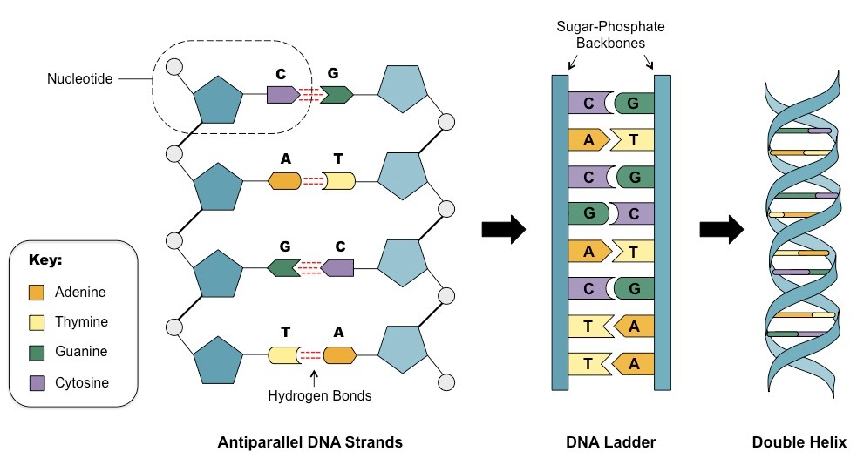

DNA Function
- DNA codes for the blue prints of life it is an information molecule

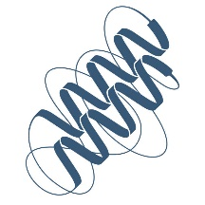

The process of DNA replication produces a full new copy of an organism’s genetic information which is passed onto a new cell.

https://www.youtube.com/watch?v=TNKWgcFPHqw

Build and Pair a DNA Strand
- Students will each randomly pick one strand of DNA.
- Students will build their DNA sequence out of coloured mini marshmallows, toothpicks and a piece of licorice (or other types of candy).
- Once built, students will need to compare their DNA strand against other students’ DNA to find the opposite matching half of DNA.
- When a match has been found, students will call the teacher over to verify their match.
- Once verified, students can eat their half of DNA.

