L #1: DNA Worksheet

Label the diagram. Use these choices: nucleotide, deoxyribose, phosphate group, nitrogen base, hydrogen bonds, and base pair.

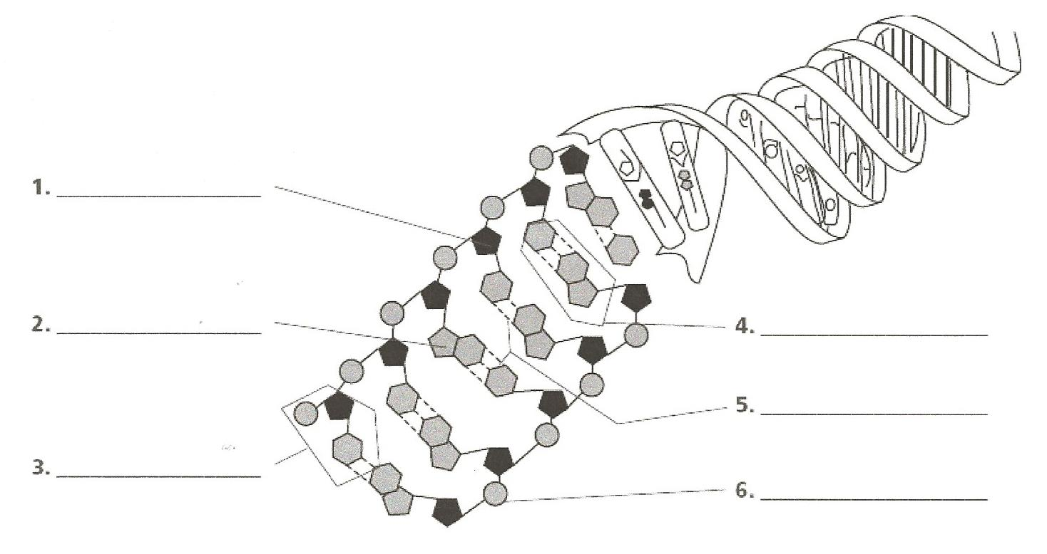

Complete each statement.
- ________________ (A), ________________ (G), ________________ (C), and ________________ (T) are the four _________________ in DNA.
- The sequence of __________________ carries the genetic information of an organism.
- The process of __________________ produces a new copy of an organism’s genetic information, which is passed on to a new cell.
- The double-coiled shape of DNA is called a __________________.
- A nucleotide is made up of three parts: a __________________ group, a five carbon __________________ and a __________________ base.
- In a strand of DNA, if the percentage of thymine is 30%, the percentage of cytosine in the same DNA strand should be __________%.

