Lesson 10: Word equations to balanced equations.

Step #1: Identify the substance as ionic or covalent.
Step #2: If the substance is an element, determine if it is diatomic.
Q: How?
A: ___________________________________________________________________________
Q: What does it mean when an element is diatomic?
A: ___________________________________________________________________________
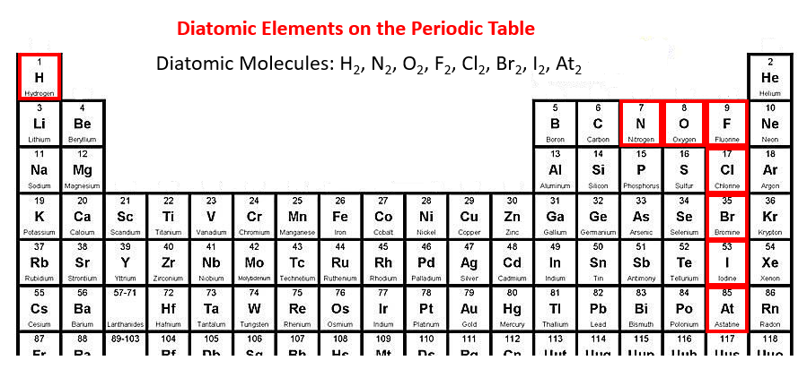
Step #3: Write the skeleton reaction (i.e., the unbalanced equation) with reactants on the left and products on the right separated by an arrow.
- Use crossing over for ____________ substances
- Use the prefix system for ___________ substances

Step #4: Balance the equation.
Example:
Word Equation: iron (III) oxide + hydrogen water + iron
Skeleton Equation:
Balanced Equation:

