Lesson 10: Word equations to balanced equations.

Step #1: Identify the substance as ionic or covalent.
Step #2: If the substance is an element, determine if it is diatomic.
Q: How?
A: Use the 7+1 rule. (See the periodic table below)
Q: What does it mean when an element is diatomic?
A: It means the element exists as a molecule made up of two of the same type of atom.
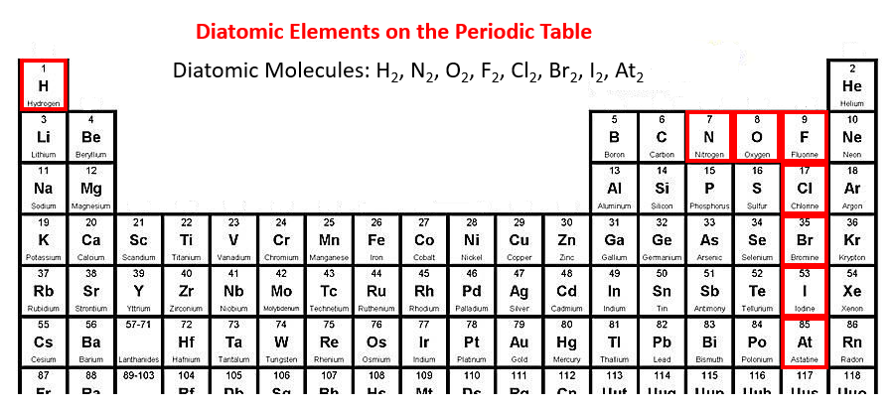

Orally: Although Astatine is in this group of elements, we will not use it as it is a very rare radioactive element that has a very short half-life.

Step #3: Write the skeleton reaction (i.e., the unbalanced equation) with reactants on the left and products on the right separated by an arrow.
- Use crossing over for ionic substances
- Use the prefix system for covalent substances

Step #4: Balance the equation.

Example:
Word Equation: iron (III) oxide + hydrogen water + iron
Skeleton Equation: Fe₂O₃ + H₂ H₂O + Fe
Balanced Equation: Fe₂O₃ + 2H₂ 3H₂O + 2Fe

Practice/Homework:
Work through several examples from BLM 2-18 and assign the rest for homework.
Extra practice will be put on Moodle.

