Bond Energy and Energy in Chemical Reactions

Learning Outcomes
- I can explain the difference between heat and temperature.
- I can explain how heat affects chemical reactions.
- I can identify chemical reactions based on whether they absorb heat or give off heat.

Heat Transfer in Chemical Reactions
- One way of classifying chemical reactions is whether they give off heat or absorb heat.

Orally: To more fully understand this statement we need to differentiate between heat and temperature.

Questions: What is the difference between temperature and heat?

Temperature
- measured as the average kinetic energy of a substance
- Kinetic Energy = $KE=\frac{1}{2}mv^{2}$
- What is Kinetic Energy then?
It is the energy a mass has from being in motion.
Orally:
Q: What is kinetic energy?
Q: What is moving in the substance?
Q: What does the motion of particles look like in a solid, liquid or gas?

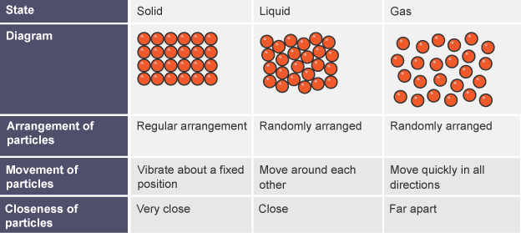
- Higher temperature more KE faster moving particles

Heat
- heat represents the flow of energy from one substance to another
- heat flows from a hotter substance to a cooler substance until they reach a common temperature (equilibrium).
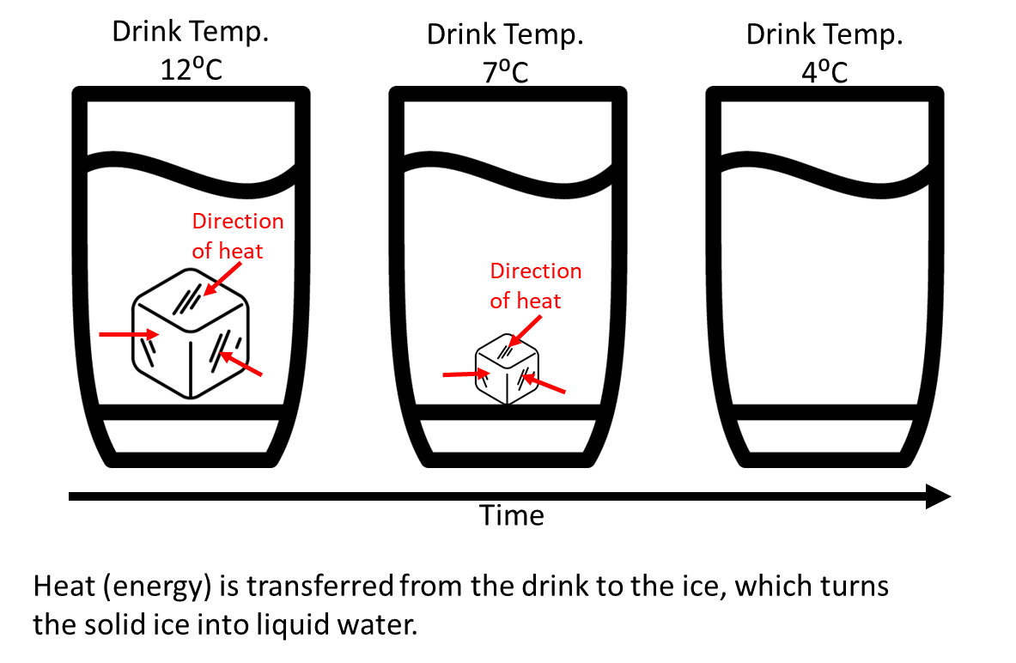
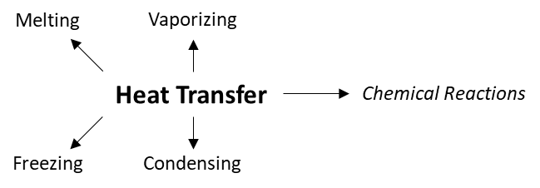

Classifying Reactions Based on Heat
- chemical reactions either release or absorb energy
- Activation Energy: the energy required to start a reaction in a chemical system
- Make or break bonds
- measured in units of joules (J) or kilojoules (kJ)

Orally: Reactions that require a lot of energy to start have a large activation energy. Some reactions do not appear to need activation energy at all but they do. E.g., rusting appears to happen spontaneously but only because there is enough energy available in the surroundings to start the reaction.

Classifying Reactions Based on Heat
- when a bond breaks, heat energy is absorbed to break that bond
- when a bond forms, heat energy is released

- Exothermic Reaction
- net energy release occurs from the chemical system to the surroundings
- energy released is often in the form of heat or light
- example: campfire
- Endothermic Reaction
- a reaction in which energy is absorbed and stored in bonds.
- the reaction feels cool or cold
- Acitvation energy is greater than total energy released
- example: chemical cold pack
Activity: Have students list examples of common exothermic and endothermic reactions and share with the class.

https://phet.colorado.edu/sims/html/states-of-matter-basics/latest/states-of-matter-basics_en.html

Assign: simulation and demonstration activity

