Covalent naming and formulas
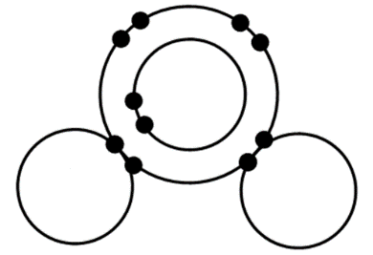
Chemical reactions occur when atoms gain, lose, or share electrons.
Sharing electrons creates a covalent bond
Nonmetals can ______________ electrons to form a covalent bond.
This creates a _______________.
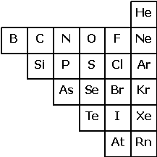
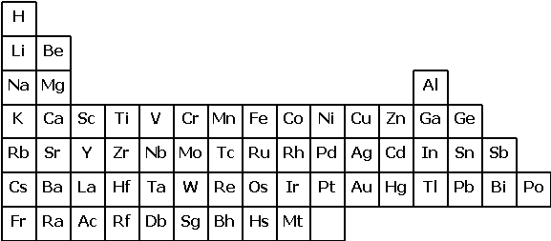
Determine if a compound is ionic or covalent.
What elements do covalent compounds contain?
Covalent compounds contain only _____________________.
What elements do ionic compounds contain?
Ionic compounds contain a ______________ and a ______________________.

Decide whether the compounds on your notes are ionic or covalent.
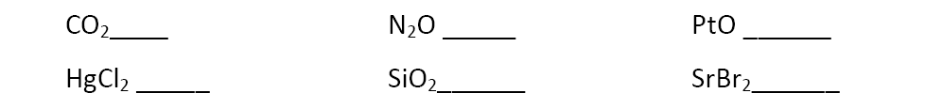

There are 7 elements that exist in nature as diatomic molecules.
What elements exist as diatomic molecules?
_____________________________________________________________________________
There are millions of covalent compounds. These can be classified into many different types of ______________________. Each type of compound has a different set of rules for naming.
Binary Covalent Compounds
What does the word binary mean? Binary means ___________.
Binary covalent compounds are between ___________________________________________.
Nonmetals can share electrons in many different ways. This means that two nonmetals can create ________________________ compounds together.
carbon and oxygen phosphorous and chlorine
_________________ _______________________
nitrogen and oxygen
_________________
Each of these contains a different ______________ of elements. Because of this, we have to make sure that the name of the compound explains the correct ratio.

To show the correct ratio of elements, we use ____________________.
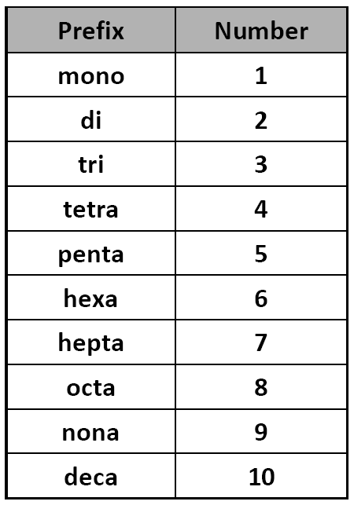
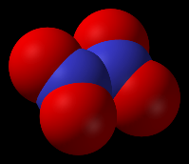
Steps for Naming Binary Covalent Compounds
Example: N₂O₄
Step 1: Write the name of the first _____________________.
Step 2: Write the name of the second nonmetal changing its ending to ___________.
Step 3: Add prefixes to specify __________________________ of each element are present.
Answer: _______________________________

Rules for Using Prefixes
Rule 1: Prefixes are only for _______________________________ compounds or greater.
Rule 2: The prefix _________________ is never used on the first element of a binary covalent compound. Without a prefix it is assumed that there is only 1.
Example: CO₂ is ______________________________, and not monocarbon dioxide.
Rule 3: Remove the -o or -a from a prefix before adding it to ____________________.
Example: CO is _____________________________, and not carbon monooxide.

How would you write each of the prefixes in front of oxide?
Remember: Remove the -o or -a from a prefix before adding it to oxide. Leave -i alone.
mono- ____________ di- ____________
tri- ____________ tetra- ____________
penta- ____________ hexa- ____________
hepta- ____________ octa- ____________
nona- ____________ deca- ____________

Name the binary covalent compounds.
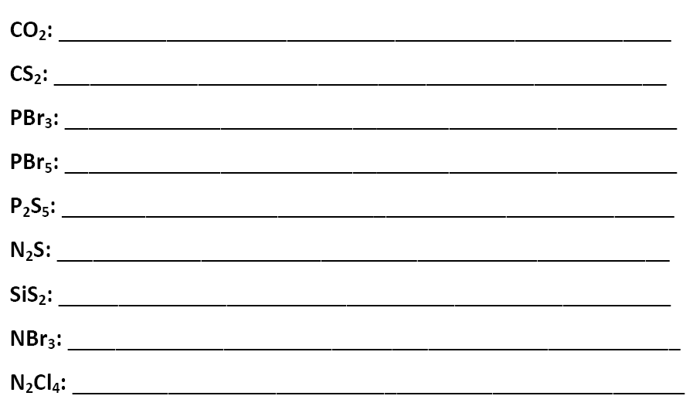

Because of the prefixes, it is very easy to go from the name of a binary covalent compound to its formula.
Example: dinitrogen tetrafluoride
Step 1: Write the symbol of the first nonmetal and the __________________ that matches the prefix.
Step 2: Write the symbol of the second nonmetal and the subscript that matches the prefix.
Answer: _____________________

Write the formulas of the binary covalent compounds in your notes.
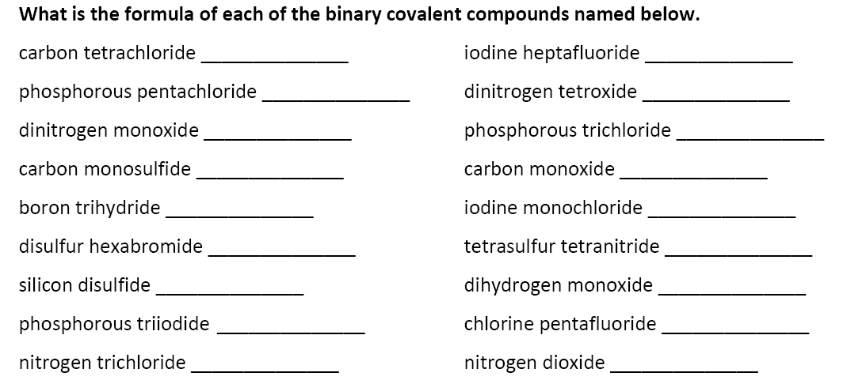

Once you decide if a compound is ___________________ or _____________________ you know whether or not to use prefixes.
Only _______________________________________ use PREFIXES!
Do NOT make the mistake of using prefixes with ___________________ compounds. You will need to be able to make this choice in upcoming assessments!

