Lesson 13 Acids & Bases

- Some chemicals can be classified as either an acid or a base.
- Both acids and bases are corrosive, which means they can burn your skin/eyes.

Acids
- Chemicals that produce _______________________ (H⁺) when dissolved in water; the _________ H⁺ ions, the _______________ the acid.
- Bronsted-Lowry Acid: A species that ______________ a proton (H⁺)
- Acids take on acidic properties when ______________ in water referred to as ______________ solutions. (Note that it is the free H+ that produces the acidity).

Ex. Hydrochloric Acid:

- ___________________ due to the hydrogen ions and anions.
- Most acids can be identified by their chemical formula starting with an “_____”
Which of the following are acids?
HCl H₂SO₄ H₃PO₄ H2O NaOH

- Many acids show up in household products such as vinegar – ______________________, pop – ________________, lemons – ___________________, etc. The ___________ flavour in these foods is due to the acid.
- Many acids show up in industrial applications such as __________________ and _______________________.
- Some animals and plants use acids as a defense mechanism such as stinging nettle and various types of ants.

Bases
- Often classified as chemicals that produce ________________________ (OH⁻) when dissolved in _______________; the more OH⁻ ions, the stronger the base. e.g., NaOH, Mg(OH)_{2.}
Ex Sodium Hydroxide:
- ____________________ due to the hydroxide ions and cations.
- Bronsted-Lawry Base: any species that accept a ________________
- Many bases used in the home are _______________; many feel _______________________ ____________________________________. (e.g. soap, oven cleaner, etc.)
- Bases are frequently used in industrial applications such as __________________________. E.g., NaOH is used to soften lignin in wood. _______________ is like a glue that holds cellulose fibers together. _________________ needs to be separated in order to make high quality paper.

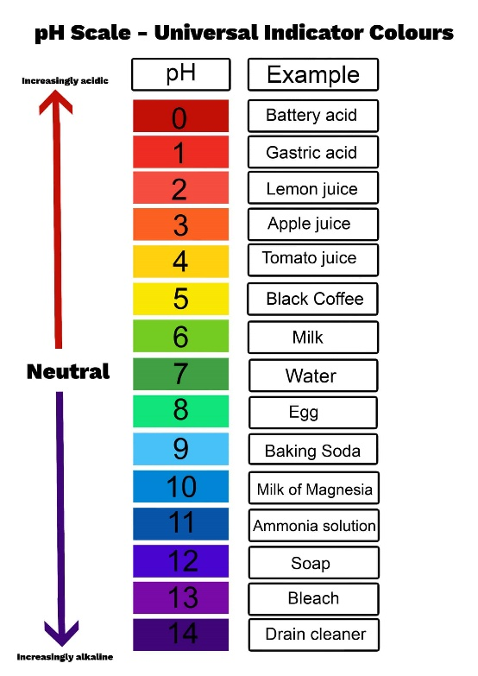
pH Scale
- The pH scale is used to identify the ________________ of an acid or base
- Numbered scale ranging from 0 (_________________________to 14 (____________________________) that increases by a factor of 10 for each whole number change on the scale
- Each jump of 1 means the acid or base is __________________ stronger
- An acid with a pH of 3 is ______ times stronger than an acid with a pH of 4 and _______ times stronger than an acid with a pH of 5.
- A pH of ______ is neutral (i.e., not acidic or basic).

pH Indicators
- pH indicators are chemicals that react with acids and bases to produce a known ___________________________.
- Example: Litmus paper changes to ______ in acids and to __________ in bases.
- Other indicators are: methyl orange, methyl red, bromothymol blue, phenolphthalein and indigo carmine. See colour indicators page from data pages.

