Lesson 13 Acids & Bases

- Some chemicals can be classified as either an acid or a base.
- Both acids and bases are corrosive, which means they can burn your skin/eyes.

Acids
- Chemicals that produce hydrogen ions (H⁺) when dissolved in water; the more H⁺ ions, the stronger the acid.

- Bronsted-Lowry Acid: A species that donates a proton (H⁺)

- Acids take on acidic properties when dissolved in water referred to as aqueous solutions. (Note that it is the free H+ that produces the acidity).

Example Hydrochloric Acid: HCl H⁺(aq) + Cl-(aq)

- Conductive due to the hydrogen ions and anions.

- Most acids can be identified by their chemical formula starting with an “H”
- e.g., HCl, H₂SO₄, H₃PO₄. (Exception: H₂O is not an acid!)

- Many acids show up in household products such as vinegar – acetic acid, pop – carbonic acid, lemons – citric acid, etc. The sour flavour in these foods is due to the acid.

- Many acids show up in industrial applications such as paper bleaching and automobile batteries.

- Some animals and plants use acids as a defense mechanism such as stinging nettle and various types of ants.

Bases
- Often classified as chemicals that produce hydroxide ions (OH⁻) when dissolved in water; the more OH⁻ ions, the stronger the base. e.g., NaOH, Mg(OH)₂

- NaOH Na⁺(aq) + OH-(aq)

- Conductive due to the hydroxide ions and cations.

- Bronsted-Lawry Base: any species that accept a proton

- Many bases used in the home are cleaners; many feel slippery and are bitter to taste. (e.g. soap, oven cleaner, etc.)

- Bases are frequently used in industrial applications such as pulp and paper. E.g., NaOH is used to soften lignin in wood. Lignin is like a glue that holds cellulose fibers together. Cellulose needs to be separated in order to make high quality paper.

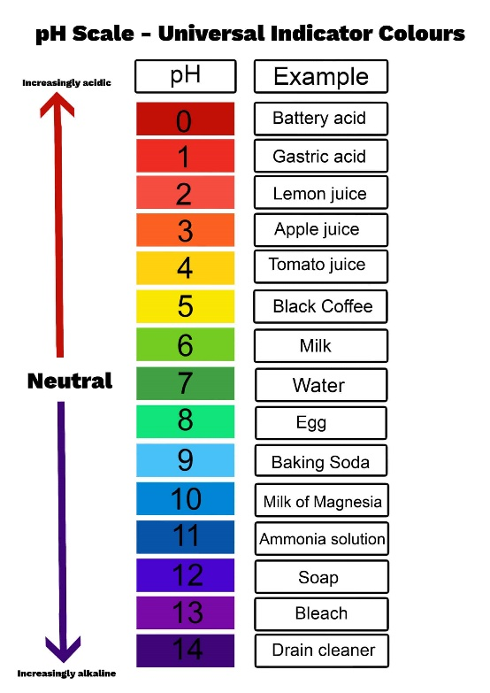
pH Scale
- The pH scale is used to identify the strength of an acid or base

- Numbered scale ranging from 0 (very strong acid) to 14 (very strong base) that increases by a factor of 10 for each whole number change on the scale

- Each jump of 1 means the acid or base is 10 times stronger

- An acid with a pH of 3 is 10 times stronger than an acid with a pH of 4 and 100 times stronger than an acid with a pH of 5

- A pH of 7 is neutral (i.e., not acidic or basic).

pH Indicators

- pH indicators are chemicals that react with acids and bases to produce a known colour change.

- Example: Litmus paper changes to red in acids and to blue in bases.

- Other indicators are: methyl orange, methyl red, bromothymol blue, phenolphthalein and indigo carmine. See colour indicators page from data pages.

