Hazardous Identification Systems
Lesson 2 - Worksheet

Identify the hazards associated with each of the following symbols.

 |  | System: ______________________________________________________  Hazard: ______________________________________________________
 | 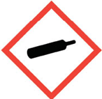 | System: ______________________________________________________  Hazard: ______________________________________________________
 |  | System: ______________________________________________________  Hazard: ______________________________________________________
 | 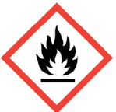 | System: ______________________________________________________  Hazard: ______________________________________________________
 |  | System: ______________________________________________________  Hazard: ______________________________________________________
 | 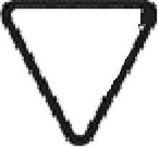 | System: ______________________________________________________  Hazard: ______________________________________________________
 | 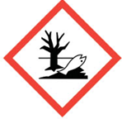 | System: ______________________________________________________  Hazard: ______________________________________________________
 |  | System: ______________________________________________________  Hazard: ______________________________________________________
 | 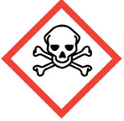 | System: ______________________________________________________  Hazard: ______________________________________________________
 | 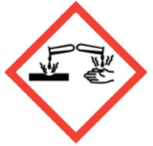 | System: ______________________________________________________  Hazard: ______________________________________________________
 | 2  1 3  W | System: ______________________________________________________  Hazard: ______________________________________________________  ______________________________________________________  ______________________________________________________  ______________________________________________________

