Hazard Identification Systems

Whether at home or in the work place, we use chemicals everyday that can be potentially harmful to us if used incorrectly. Correctly identifying what these hazards are is essential to the safe use of these products. There are three methods of identifying hazardous materials that you need to be aware of.

_____________________________________________________________

WHMIS is Canada’s national system for identifying hazardous materials. This system uses a set of eight symbols to designate different classes of hazardous materials. It is the common type of safety labeling used in all industries and government worksites as mandated by federal regulations.

Atypical label for a container looks like:

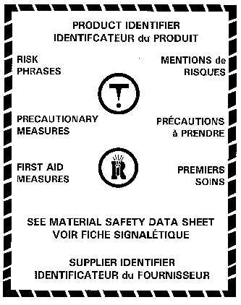

The “Risk Phrases” and “Precautionary Measures” are also standardized and come from a common databank. This ensures that all people understand the associated risks of the product regardless of where in Canada they live or move to.

In addition to the WHMIS labels, a place of business must also keep a Material Safety Data Sheet (MSDS) for each hazardous product that they keep on site. The MSDS for a chemical includes all of the pertinent information, such as chemical makeup, supplier name, first aid measures, and safety precautions.
WHMIS Symbols

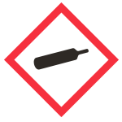 | Gas Cylinder  This class includes ________________________ gases, ________________________ gases, and gases ____________________ by compression or ___________________.
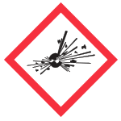 | __________________________  for ____________________ or ______________________ hazards under _____________________ working conditions.
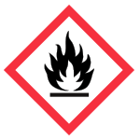 | Flame  This class includes any substance or mixture (solid, liquid, aerosol or gas) that may catch fire in the _____________ of a _______________ or _______________ flame. They may also emit a flammable gas in ________________________________. It also includes any self-reactive or self-heating
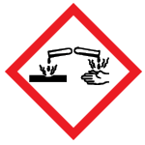 | _________________________  This class includes caustic and acid materials that can ___________________ metals or cause ___________________ ______________________ or damage to ____________ or __________________. Examples: sodium hydroxide, hydrochloric acid, nitric acid
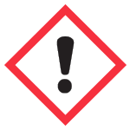 | Exclamation Mark  may cause less serious health effects such as:  - __________________________________  - skin sensitivity  - single exposure specific target organ toxicity - drowsiness/dizziness or respiratory irritation  or ____________________________________________
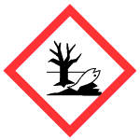 | _____________________________  may cause both short and long-term damage to the aquatic environment
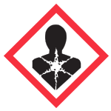 | Health Hazard  These materials can cause or are _________________ of causing serious health problems. They may be life-threatening and have serious long-term health consequences. As well as less severe but immediate reactions in a person who is repeatedly exposed to small amounts.
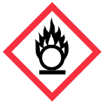 | _________________________________  These materials _________________________ of fire if they come in contact with flammable or combustible materials.
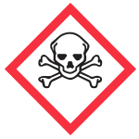 | Skull & Crossbones  can cause _____________________or ______________________ with short exposure to small amounts
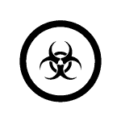 | Biohazardous infectious materials  - for _________________________or _______________________ that can cause diseases in people or animals

Hazard Identification System (HIS)

This system uses a colour-coded set of four boxes arranged either as a diamond or as a large box. Three of the boxes are colour-coded for health (blue), flammability (red) and yellow (reactivity), and use a number scale (0-4) to indicate the hazard level. The fourth box is left white and indicates other potential hazards not covered by the other three boxes.
________________________________

F

______________________
___________________________
R
H

SC

____________________________

Health (Blue)
4 Can cause death or major injury despite medical treatment.
3 Can cause serious injury despite medical treatment.
2 Can cause injury; requires prompt treatment.
1 Can cause irritation if not treated.
0 No hazard.

Fire (Red)
4 Very flammable gases or very volatile flammable liquids.
3 Can be ignited at all normal temperatures.
2 Ignites if moderately heated.
1 Ignites after considerable preheating.
0 Will not burn

Reactivity / Stability (Yellow)
4 Readily detonates or explodes.
3 Can detonate or explode, but requires a strong initiating force or heating under confinement.
2 Normally unstable but will not detonate.
1 Normally stable; unstable at high temperature and pressure; reacts with water.
0 Normally stable; not reactive with water.

Special Comments (White)
C May be carcinogenic with chronic exposure.
SC Suspected carcinogen.
Exp Risk of explosion.
W Reacts with water.
Cor Corrosive.
Oxy Oxidizing agent.
T Toxic.
Pol Polymerizes under normal conditions.
Household Hazardous Products Symbols (HHPS)

This system uses a set of four symbols and two borders to identify a potential danger from either the container or the contents.

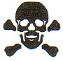  ______________________ |   ______________________ | 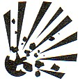  ______________________
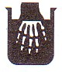  ______________________ | ______________________ | ______________________

On many household products, you may see the following combinations.

Symbol | The Danger | Product Example
 | This container can ____________ ___________________________ Flying pieces of metal or plastic can cause serious injuries, especially to the eyes. | Chemicals in aerosol containers such as _____________________ _____________________.
 | This product is _______________. It will burn skin or eyes on contact, or throat and stomach if swallowed. | _____________________ _____________________  _____________________ _____________________
 | This product is _______________. It, or its fumes, will ____________ _______________________ if it is near heat, flames or sparks. | Products such as ________ _____________________ ______________________
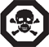 | This product is poisonous. _____________________________ ___________________________ or sometimes smelling this product will cause illness or death. | Products such as _____________________ _____________________.  _____________________ _____________________.

Name:

Hazardous Identification Systems
Worksheet

Identify the hazards associated with each of the following symbols.

1. |  | _________________________________________________  _________________________________________________
2. |  | _________________________________________________  _________________________________________________
3. |  | _________________________________________________  _________________________________________________
4. | 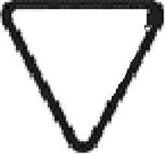 | _________________________________________________  _________________________________________________
5. |  | _________________________________________________  _________________________________________________
6. |  | _________________________________________________  _________________________________________________
7. |  | _________________________________________________  _________________________________________________
8. | 2  3 1  W | _________________________________________________  _________________________________________________  _________________________________________________  _________________________________________________

