8.3 Scale Diagrams
A is a reproduction of an object. It is either or than the original, but it has the (ie. It is ). Each dimension of the figure is multiplied by the same .
Scales can be stated several ways:
As a eg. 1 cm = 50 km
As a eg. $\left(\frac{1 cm}{50 km}\right)$
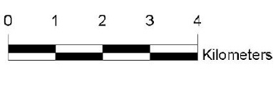
As a eg. (1: 5 000 000)
As a eg.

If the image length is than the object length then the scale factor is and we have an .
If the image length is than the object length then the scale factor is and we have a .

Scale is ALWAYS written in the form of:

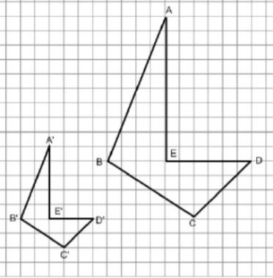

Find the scale factor from the diagram:

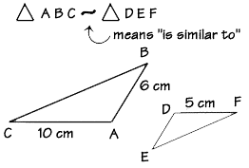
These two triangles are similar. Find the length of DE.

Surveyors are using a measuring device called a tight-chain to determine boundaries of plots of land. Two surveyors determine that a proposed building site is rectangular, measuring 175 m x 50 m. To make a scale drawing of the site, they use a scale of 1 : 2500.
What are the dimensions of the scale drawing of the building site in centimetres?

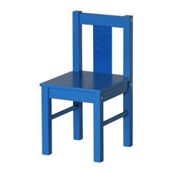
A doll house is $\frac{1}{10}$ of the actual size of a house. If a chair in the dollhouse is 2.75 cm tall, how tall is the actual chair that it models?

Ex. A tree casts a shadow 3.2 m long. At the same time a 1.7 m tall man standing near the tree casts a shadow 0.8 m long. Determine the height of the tree to the nearest tenth.

Page 479: 1-4, 6, 13, 14

