8.1 Comparing & Interpreting Rates
A ratio is and can be written ways:

- .
- .

A rate is a of .
World class sprinters can run 100m in about 9.8s. If they could run at this rate for a longer period of time, estimate how far they could run in a minute and an hour.

A unit rate is a in which the is equal to .
Which is the better buy? 200g of coffee beans for $3.85 or 1 pound of coffee for $9.60?
Need to know:


Your fingernails grow at about 0.8 mm/week. Your toenails grow at about 19.2 mm/year. Do your toenails or fingernails grow faster? By how much?

Paper towels are sold in a 2 roll package for $2.49 and a 12 roll package for $12.99.
What package has the lower unit price?

How much would you save by buying a 12 roll package rather than six 2 roll packages?

When deciding which package size is the better buy for you, what should you consider in addition to the unit price?

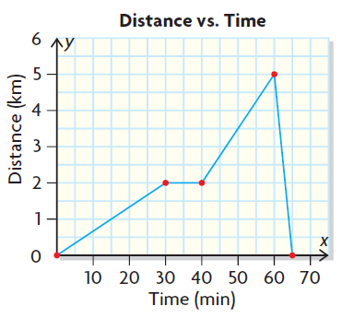
Describe a scenario that could be represented by this graph. Compare the rates (hint: slope of a line!) shown, and discuss why the rates may have changed.

When making a decision about buying a car, one factor some consumers consider is fuel efficiency.
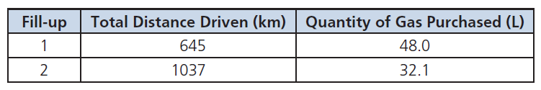
The gas tank on Mario’s new car has a capacity of 55 L. The owner’s manual claims that the fuel efficiency is 7.6 L/100 km on the highway. Use the information Mario recorded below to determine on which leg of the trip his fuel economy was the best.

Page 459: 1-10, 12, 13, 15

