7.7: Solving Systems of Equations Graphically
Linear-Quadratic Systems: Given a line and a parabola, three situations may occur:

Solutions to a System of Equations means

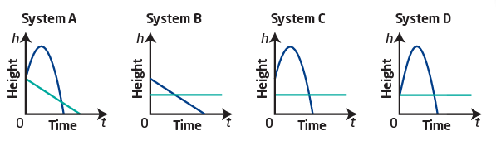
Blythe Hartley, of Edmonton Alberta, is one of Canada’s best springboard divers. She is doing training dives from a 3 m springboard. Her coach uses video analysis to plot her height above the water.

a) Which system could represent the scenario? Explain.

b) Interpret the point(s) of intersection in the system you chose.


Solve by graphing. Verify.
x – y + 1 = 0
y = -(x – 3)² + 6

Quadratic-Quadratic Systems: Four situations may occur:

Solve using technology. Include a window sketch. Verify your answers.
y = -2x² + 5
y = -2(x + 3)² - 1

2x² - 16x – y = -35
2x² + 8x – y = -11

Is (-3,2) a solution to the following system?
3x – 4y = -17
x² – 2x + 3y – 3 = 0

Assignment: worksheet

