7.6.2 Vertex Form of a Quadratic Function
We have practiced drawing graphs given the quadratic function. What if you are given the graph and need to write the quadratic function? (No problem, right!?)
Write the equation of each parabola graphed below.

- b)

______________________________ ___________________________

Assignment: Complete attached worksheet, question 1 below & page 417, #2, 11
1. For each graph below, write the equation in vertex form.
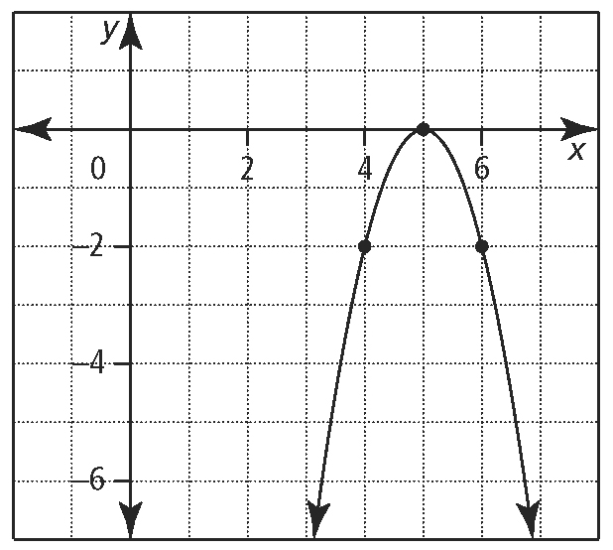
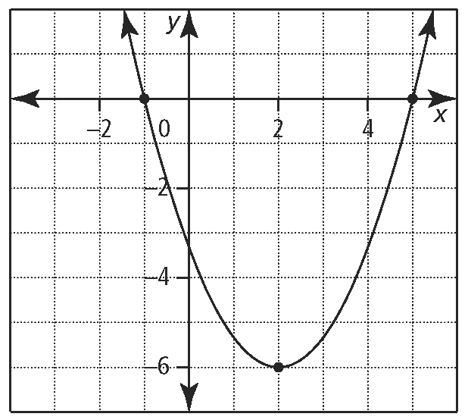
a. b. c.


