7.4 Factored Form of a Quadratic Function
Recall: Standard form of a quadratic:

Factored form of a quadratic: __________________________________________
What is the connection between factored form of a quadratics and the x-intercepts of the equation? Graph the following quadratic equations and find the x-intercepts. Can you make a conjecture about the factored form of a quadratic and the x-intercepts of the equation?
- $2\left(x-4\right)\left(x+5\right)=0$ 2. $-\left(x-1\right)\left(x-8\right)=0$
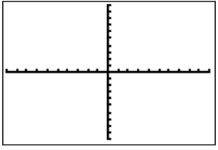

- $x\left(x+3\right)=0$ 4. ${(x+2)}^{2}=0$

Example 1: Graph the quadratic function $y=2x^{2}+14x+12$ using your graphing calculator. Be sure to sketch the window. State the domain and range.

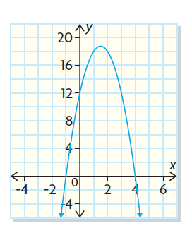
Example 2: Determine the equation (standard form) of each graph.

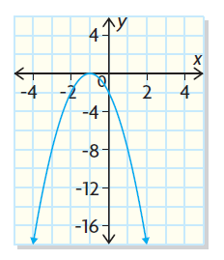


Using the graph of quadratic functions to solve problems:
Example 3: The members of a Ukrainian church hold a fundraiser every Friday night in the summer. They usually charge $6 for a plate of perogies. They know, from previous Fridays, that 120 plates of perogies can be sold at this price, but, for each $1 price increase, 10 fewer plates will be sold. What should the members charge so that they raise as much money as possible?

