F Math 11 7.3 Solving Quadratic Equations by Graphing p. 373

Quadratic Equation:
Zero:
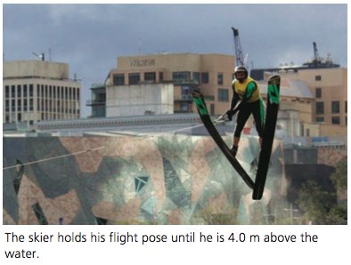
Example 1: Verifying solutions to a quadratic equation (p. 374)
The flight time for a long-distance water ski jumper depends on the initial velocity of the jump and the angle of the ramp. For one particular jump, the ramp has a vertical height of 5 m above water level. The height of the ski jumper in flight, $h(t)$, in metres, over time, $t$, in seconds, can be modelled by the following function:

$$h\left(t\right)= 5.0+24.46t-4.9t^{2}$$

How long did the skier on the right hold his flight pose?

Roots:
Example 2: What are the roots for x² – 6x + 9 = 0?

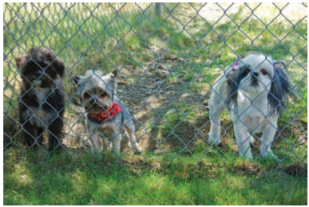
Example 3: Graphing to determine the number of roots (p. 376)
Lamont runs a boarding kennel for dogs. He wants to construct a rectangular play space for the dogs, using 40 m of fencing and an existing fence as one side of the play space.
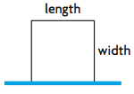
- Write a function that describes the area, $A$, in square metres, of the play space for any width, $w$, in metres.

- Write equations you could use to determine the widths for areas of 250 m², 200 m², and 150 m².

- Determine the number of possible widths for each equation using a graph.

Example 3: Solving a quadratic equation in non-standard form (p. 378)
Determine the roots of this quadratic equation. Verify your answers.
$$3x^{2}-6x+5=2x\left(4-x\right)$$

Page 379: #5-7, 9, 11

