7.2 Properties of Graphs of Quadratic Functions
Recall: When graphed, a quadratic function forms a parabola. We know that the imaginary vertical line down the center of the parabola is called the .
The degree of a quadratic function is
Vertex:
Using your graphing calculator, graph the equation, sketch the window and identify the vertex.
y = x² + 2x – 3

y = -4x² + 5x - 12

Some children are playing at the local water park. The water jets spray water from ground level. The path of the water from one of these jets forms an arch that can be defined by the function $f\left(x\right)=-0.12x^{2}+3x$ where x represents the horizontal distance from the opening in the ground in feet and f(x) represents the height of the water, also in feet. What is the maximum height and how far from the opening in the ground can the water reach?
x | y
0
5
10
15
20
25

Axis of symmetry

Vertex

Maximum height?

How far can the water reach?

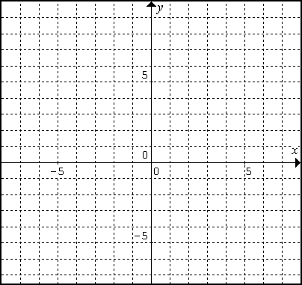
Graph $y=x^{2}+x-2$. Determine the y-intercept, x-intercept, equation of the axis of symmetry, domain and range of the function.
x | y
-2
-1
0
1
2

Using your calculator to find the vertex of a parabola:
A skier’s jump was recorded in frame-by-frame analysis and placed in one picture, as shown. The skier’s coach used the picture to determine the quadratic function that relates the skier’s height above the ground, y, measured in meters, to the time, x, in seconds that the skier was in the air: $y=-4.9x^{2}+15x+1$. Find the maximum height reached by the skier.

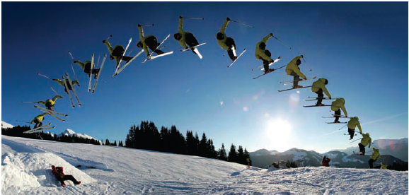

Page 368: 1-6, 9, 10, 12-14

