6.4 Optimization Problems 1: Creating the Model
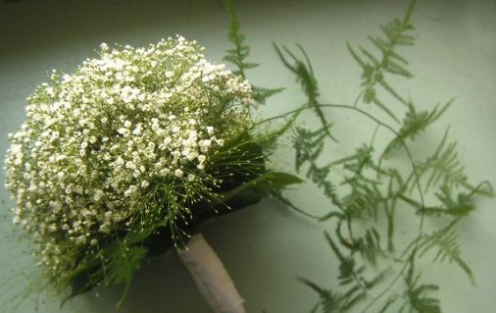
A florist is ordering bracken fern and baby’s breath for bouquets and centerpieces. No more than 100 stems of baby’s breath will be ordered but more than 100 bracken fern will be ordered. The florist has space to store no more than 250 stems in total. Determine which of the following combinations will fit these criteria.
Baby’s  Breath | 0 | 25 | 50 | 100 | 95.5 | 100 | 150
Bracken  Fern | 150 | 25 | 150 | 100 | 114.5 | 150 | 125
Possibility?

Investigate: A toy company manufactures two types of toy vehicles: racing cars and SUVs. Because the supply is limited, no more than 40 racing cars and 60 SUVs can be made each day. The company can make 70 or more vehicles, in total, per day. It costs $8 for racing cars and $12 for SUVs. There are many possible combinations of racing cars and sport-utility vehicles that could be made. The company wants to know what combinations will result in the minimum and maximum costs, and what those costs will be.
- What are the two variables in this situation?

- Write a system of three linear inequalities to represent these conditions:
- The total number of racing cars that can be made.

- The total number of SUVs that can be made.

- The total number of vehicles that can be made.

- What do you know about the restrictions on the domain and range of the variables? Explain.
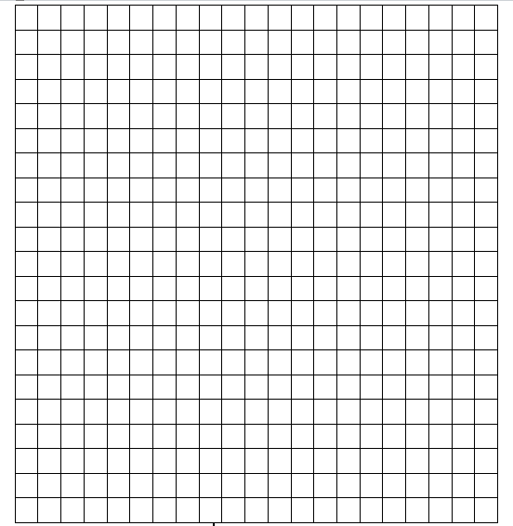

- Graph the system. Choose at least
two points in the solution region that
are possible solutions to the system.

- What quantity in this situation needs to be minimized and maximized? Write an equation to represent how the two variables relate to this quantity.

- Use your equation from part 5 to calculate the manufacturing cost of each combination below.
- 40 racing cars and 60 SUVs
- 40 racing cars and 30 SUVs
- 10 racing cars and 60 SUVs
- 30 racing cars and 40 SUVs
Optimization problem __________________________________________________
__________________________________________________________________
Constraint __________________________________________________________
__________________________________________________________________
Objective function ___________________________________________________
__________________________________________________________________
Feasible region ______________________________________________________
__________________________________________________________________
Example: A refinery produces oil and gas. At least 2 L of gasoline is produced for each liter of heating oil. The refinery can produce up to 9 million liters of heating oil and 6 million liters of gasoline each day. Gasoline is projected to sell at $1.10/L and heating oil at $1.75/L. The company needs to determine the daily combination of gas and heating oil that must be produced to maximize revenue.

Page 330: 2, 3, 5-7

