6.3 Graphing Systems of Linear Inequalities
To graph a system of linear inequalities:
- Graph each _____________ as before. Pay attention to _________ or __________ lines and _________________ on the domain.
- Clearly indicate the _________________. This is the region on the grid where the shaded sections _________________.
- If the shaded sections do not ________________, there is _______________.
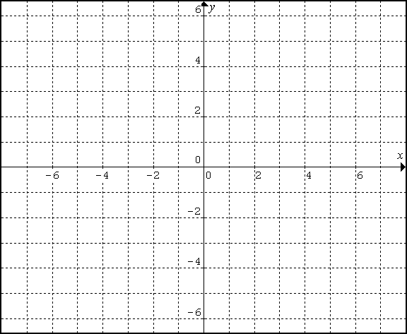
Example 1: Graph the solution set for the following system of inequalities. Choose two possible solutions from the set.
$$3x+2y>-6 y≤3$$

How would the solution region change if $x∈I, y∈I$? How would it stay the same?

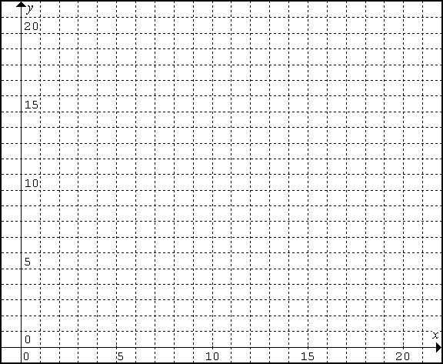
Example 2: Graph the solution set for the following system of inequalities. Choose two possible solutions from the set.
$$x+5≤y x+y<20$$
$x∈W, y∈W$ $x∈W, y∈W$

Example 3: A sloop is a sailboat with two sails: a mainsail and a jib. When a sail is fully out or up, it is said to be “out 100%”. When the winds are high, sailor often reef, or pull in, the sails to be less than their full capability. Jim is sailing in winds of 22 knots, so he wants no more than 80% of the mainsail out. He also wants more mainsail than jib. What possible combinations of mainsail and jib can Jim have out?
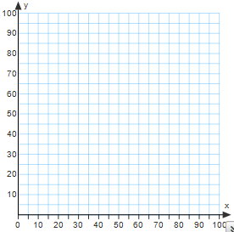

Example
To raise money, Athletics is selling 500 T-shirts. The T-shirts are red or blue. Based on previous years’ sales, they expect to see at least twice as many blue as red T-shirts.
Write a system of linear inequalities to represent this situation.

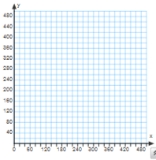

Graph the system.

What are 3 possible solutions to this situation?

Page 317: 2, 4, 6-8, 10, 11

