6.2 Exploring Systems of Linear Inequalities
Graph this system of linear inequalities. Justify your representation of the solution set.
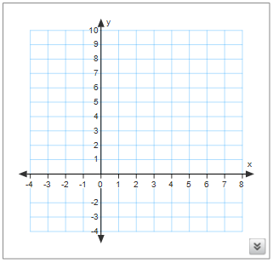
$\left\{\left(x,y\right)|x+y≤5,x∈I, y∈I\right\}$ $\left\{\left(x,y\right)|x+3y>0,x∈I,y∈I\right\}$
- Type of line

- Points on each line

- Test points

- Graph inequality

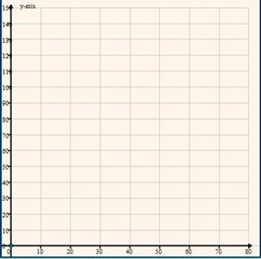
A nursery school serves morning and afternoon snacks to its students. The morning snacks are fruits, vegetables and juice and the afternoon snacks are cheese and milk. The school can accommodate 50 students or few altogether. Students can attend all day or just the morning. The morning snacks cost $1 per week per student and the afternoon snack costs $2 per week per student. The weekly snack budget is $120. What combinations of morning and full-day students can the school accommodate and stay within the weekly budget?

System of Linear Inequalities ____________________________________________
_________________________________________________________________
________________________________________________________________
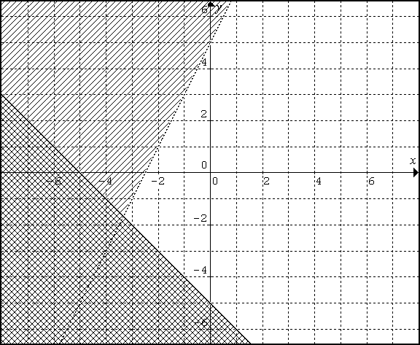
Eg:
$y>2x+5$
$y≤-x-5$

Need to Know:
Graph all the inequalities in a system of linear inequalities on the . The area in which all the solution regions overlap represents .
The solution region for a system of linear inequalities can be . It may be restricted to certain quadrants.
If the solution regions do not overlap, then the system

Assignment: 6.2 Worksheet

