5.5 Z-Scores
The more we analyze data, the more in-depth our analysis can become.
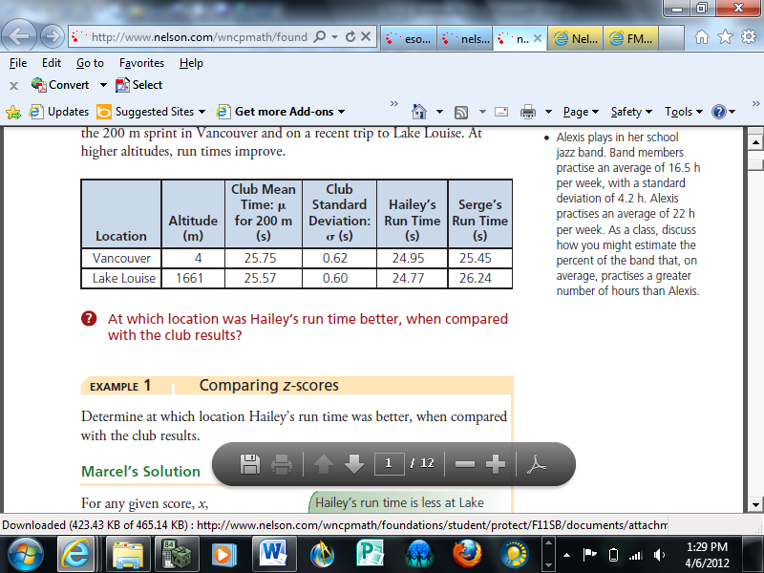
Hailey and Serge belong to a running club in Vancouver. Part of their training involves a 200 m sprint. Below are normally distributed times for the 200 m sprint in Vancouver and on a recent trip to Lake Louise. At higher altitudes, run times improve.
At which location was Hailey’s run time better, when compared with the club results?

Notice that Hailey’s run time is less at Lake Louise but so is the club’s. To make comparisons, the data must be standardized. We can use z-scores to accomplish this.
Standard normal distribution __________________________________________
________________________________________________________________
Z-Score _________________________________________________________
________________________________________________________________
Z-Score Calculation Formula

is the data value
is the mean of the data set
is the standard deviation
Compare Hailey’s Z-Scores for the two locations. Use this to determine the location where Hailey’s run time was better.

What does it mean to have a Z-Score that is:
- Negative? __________________________________________________
- Positive? ___________________________________________________
- Zero? _____________________________________________________
IQ tests are sometimes used to measure a person’s intellectual capacity at a particular time. IQ scores are normally distributed, with a mean of 100 and a standard deviation of 15. If a person scores 119 on an IQ test, how does this score compare with the scores of the general population?

Using a Z-Score Table: Using the Graphing Calc:
(Calculating the area under the normal curve and to the left of the Z-Score.)
2nd Vars (Distr)
2: normalcdf(
Normalcdf(start, stop, $μ, σ$) Enter
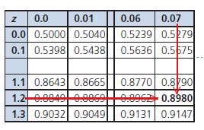

What does this mean?

How would an IQ score of 78 compare to the general public?

Athletes should replace their running shoes before the shoes lose their ability to absorb shock. Running shoes lose their shock-absorption after a mean distance of 640 km, with a standard deviation of 160 km. Zack wants to replace his running shoes at a distance when only 25% of people would replace their shoes. At what distance should he replace his shoes?
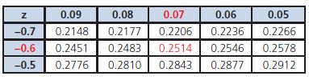
Using a Z-Score Table: Using the Graphing Calc: (Finding a score)
2nd Vars (Distr)
3: invnorm(
invnorm(percent below, $μ, σ$) Enter

The ABC Company produces bungee cords. When the manufacturing process is running well, the lengths of the bungee cords produced are normally distributed, with a mean of 45.2 cm and a standard deviation of 1.3 cm. Bungee cords that are shorter than 42.0 cm or longer than 48.0 cm are rejected by the quality control workers. If 20 000 bungee cords are manufactured each day, how many would you expect the quality control workers to reject?
Using Tables: Using Graphing Calculator:

A client has placed an order for 12 000 bungee cords but will only accept bungee cords that are between 44.0 cm and 46.0 cm in length. Can this client’s order be filled by one day’s productions, with the equipment operating as is? Explain.

Need to Know:
- Use normalcdf(…) if
- Use invnorm(…) if

Page 264: 5, 6, 8-11, 13, 16, 19, 21

