5.4 The Normal Distribution
Investigating the Normal Curve:
Complete the frequency table below recording the results for the following task: Roll a pair of dice 30 times and record the sum each time.
2 | 3 | 4 | 5 | 6 | 7 | 8 | 9 | 10 | 11 | 12
Add your results to those of the rest of the class. When all data has been accumulated, enter the sum as L1 and the frequency as L2 in your graphing calculator. To see what the results look like:

- 2nd StatPlot
- 1
- On
- Type: histogram
- Xlist: L1
- Freq: L2
- Graph

Sketch the resulting graph below.

Normal Curve ___________________________________________________________
_____________________________________________________________________
Normal Distribution ______________________________________________________
_____________________________________________________________________
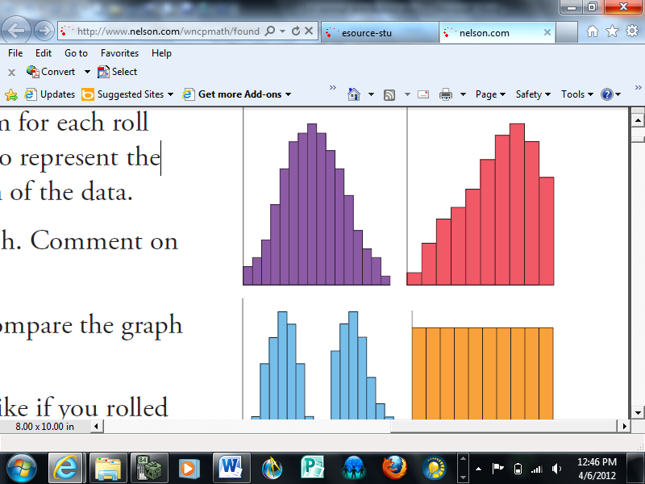
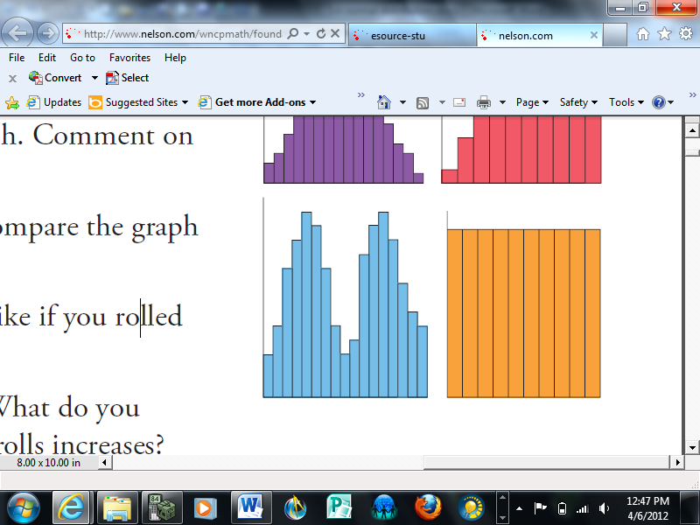
For each graph below, describe the data in terms of number of modes, distribution and what the data might possibly represent.

What’s so special about the normal distribution?
- _____% of the data are within _____ standard deviation of the ____________.
- _____% of the data are within _____ standard deviations of the ____________.
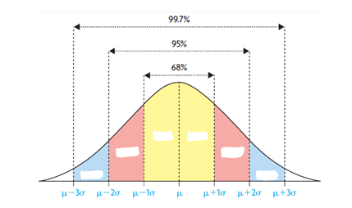
- _____% of the data are within _____ standard deviations of the ____________.

Example 1: Jim raises Siberian husky sled dogs at his kennel. He knows, from the data he has collected over the years, that the weights of adult male dogs are normally distributed, with a mean of 52.5 lb and a standard deviation of 2.4 lb. Complete the normal curve below, labeling the weights of the dogs along the horizontal axis.
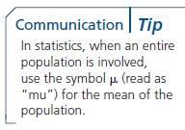
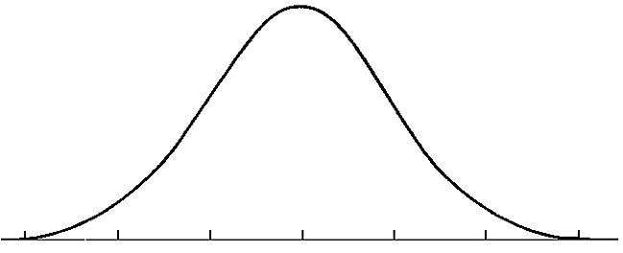

What percent of adult male dogs at Jim’s kennel would you expect to have a weight between 47.7 lb and 54.9 lb?

What percent of adult male dogs at Jim’s kennel would you expect to have a weight between 50.1 lb and 59.7 lb?

What percent of adult male dogs at Jim’s kennel would you expect to have a weight less than 45.3 lb?

Team | $μ$ (kg) | $σ$ (kg)
Men | 6.35 | 1.04
Women | 6.35 | 0.59
Example 2: Two baseball teams flew to the North American Indigenous Games. The members of each team had carry-on luggage for their sports equipment. The masses of the luggage were normally distributed, with the characteristics shown in the table.
- Sketch a graph to show the distribution of the masses of the luggage for each team.

- The women’s team won the championship. Each member received a medal and a souvenir baseball, with a combined mass of 1.18 kg which they packed in their carry-on for the trip home. Sketch a graph that shows how the distribution of the masses of their carry-on luggage changed for the flight home compared to the flight there.

Does data approximate a normal distribution?

Prior to purchasing a new cellphone, Shirley does a lot of research. She determines that the mean number of years a cellphone lasts is 2.526, with a standard deviation of 0.482 years and a median of 2.55 years. Using this information
- What is the likelihood that a new cellphone will last more than three years?

- What is the likelihood that a new cellphone will last at least 18 months?

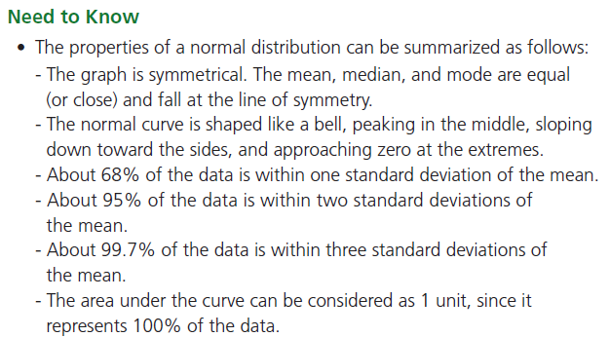

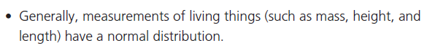

Page 251: 1, 4, 6, 7, 10, 11, 13-15

