5.1 Exploring Data
Sometimes, comparing the mean, median and mode is not enough to compare data.
Paul needs a new battery for his car. He is trying to decide between two different brands. Both brands are the same price. He obtains data for the lifespan, in years, of 30 batteries of each brand, as shown below.
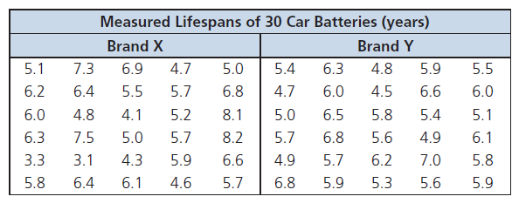
1. Describe how the data in each set is distributed. Describe any similarities and differences between the two sets of data.

2. Calculate the mean, median and mode for each battery type.

3. Define dispersion.

4. Explain why the mean and median do not fully describe the difference between the two brands of batteries. Explain what additional information can be learned from the range of the data.

5. Is the mode useful to compare in this situation? Explain.

6. Suppose that one battery included in the set of data for brand Y is defective, and its lifespan is 0.5 years instead of 5.9 years. Could this affect Paul’s decision? How?

Statistical calculations involving large data sets can be time consuming. To use the graphing calculator to calculate mean and median:
1. You must enter the data into your calculator. There are two ways to do this:
a) 2nd {1, 2, 3, 4, 5, 5} sto 2nd L1
b) STAT EDIT 1 Edit… enter data down the appropriate column using down arrow key or ENTER button.
2. To get your calculator to now calculate the mean and median:
STAT CALC 1: 1-Var Stats 2nd L1 ENTER.
What is your calculator telling you?
$\overline{x}$= $\sum{x}$= n=

Use your down arrow:
Med=

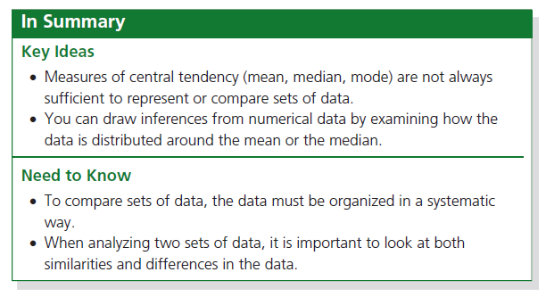

Page 211: 1-3

