Date __________________ Name______________________
Chapter 5 Getting Started
Comparing Salaries
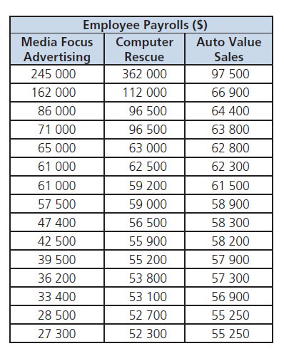
The payrolls for three small companies are shown in the table. Figures include year-end bonuses. Each company has 15 employees. Sam wonders if the companies have similar “average” salaries.

What is the best indicator of an “average” salary for each company?

1. What is the range of salaries for each company?
 | Media Focus | Computer Rescue | Auto Value
Range

2. Examine the data. Which companies have data that would be considered outliers? Tell how you know.

3. Determine the measure of central tendency (mean, median & mode) for the salaries for each company.
 | Media Focus | Computer Rescue | Auto Value
Mean
Median
Mode

4. Which measure of central tendency is most affected by outliers?

5. Create a line plot for each of the three companies. Look for outliers, measure of central tendency, and the range on your line plots. Which of these features are easily visible?

6. Which measure of central tendency best illustrates the “average” salary for each company? Why?
 | Measure | Why?
Media Focus
Computer Rescue
Auto Value

What do YOU think?
Decide whether you agree or disagree with each statement. Explain your decision.
A. To compare two sets of data, you need only the mean, the median and the mode.

B. Most sets of data are evenly distributed about their mean.

C. By looking at the data for a survey, you can decide if the results for the sample that was surveyed closely match the results you would get if you surveyed the whole population.

