2.4: Angle Properties in Polygons

Investigating the INTERIOR angle sum of polygons
Complete the table below to help you make a conjecture about the interior angle sum of any n-sided polygon.
Polygon | Number of Sides | Sketch | Number of Triangles | Sum of Interior Angles
Triangle | 3 |  | 1 | 180°
Quadrilateral | 4 |  | 2 | 360°
Pentagon
Hexagon
Heptagon
Octagon
n-gon

Use your conjecture to predict the interior angle sum of a dodecagon (12 sides). Verify your prediction using triangles.

Investigating the EXTERIOR angle sum of polygons
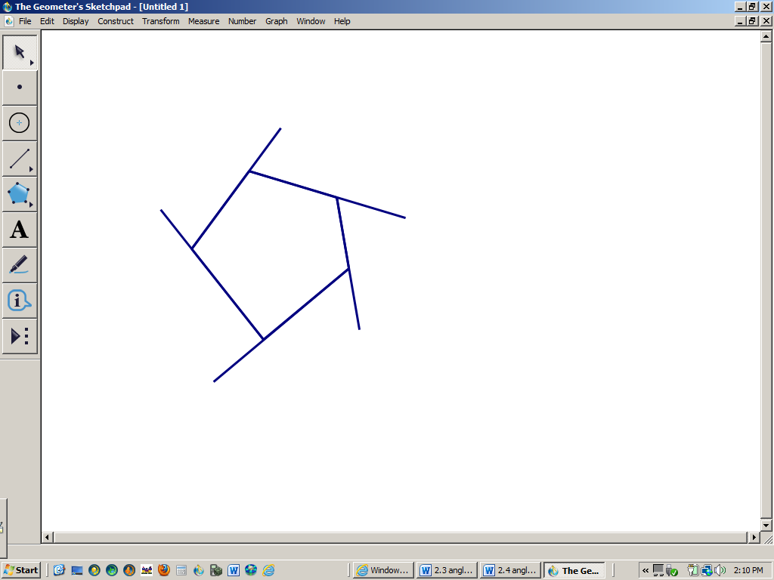
Find the exterior angles in each diagram below. (not drawn to scale)
a. b.

Use inductive reasoning to make a conjecture about the exterior angle sum of a polygon.

Use deductive reasoning to prove your conjecture.

Convex polygon ____________________________________________________
____________________________________________________

Concave polygon ____________________________________________________
____________________________________________________

Regular polygon ____________________________________________________
____________________________________________________

To summarize our results from our previous investigations:
Interior angle sum of a Exterior angle sum of a Interior angle of a
Convex polygon: convex polygon: regular convex polygon:

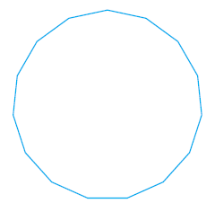
Determine the measure of each interior angle of a regular 15 sided polygon (pentadecagon).

P 99 1 a & b, 2-5,8 ab, 9, 13a, 14

