2.3: Angles and Triangles

Can we prove that the sum of the measures of the interior angles of any triangle is 180° ?
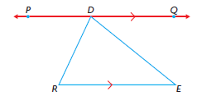

Example 1:
In the diagram, ∠MTH is an exterior angle of ∆MAT. Determine the measures of the unknown angles in ∆MAT.
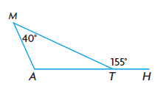

If you are given one interior and one exterior angle of a triangle, can you ALWAYS determine the other interior angles of the triangle? Explain with words and diagrams.

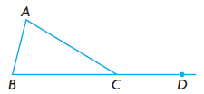
Non-adjacent interior angles: _________________________________________
_________________________________________
_________________________________________

Example 2:
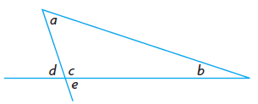
Prove ∠e = ∠a + ∠b

Example 3:
Determine the measure of
∠NMO, ∠MNO, and ∠QMO.
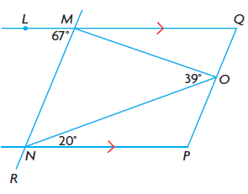

P 90 1-7, 9, 11, 14, 15, Triangle w/s

