2.2.2: Parallel Lines & Deductive Reasoning

Curricular Competencies
B3: I can apply flexible and strategic approaches to problems
C1: I can explain and justify math ideas and decisions
We have been using deductive reasoning to find missing angles in diagrams. Sometimes, mathematicians use deductive reasoning in the form of a ______ ___________________________. Remember, one of the premises of deductive reasoning is that one bit of information leads to another bit of information and so on.
Transitive property: _______________________________________________________________
________________________________________________________________________________
Example 1: When a transversal intersects a pair of parallel lines, prove the alternate interior angles are equal.
Statement | Justification
Sketch:

Example 2: One side of a cellphone tower will be built as shown. Use the angle measures to prove that braces CG, BF, and AE are parallel.
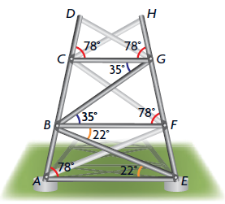
Statement Justification .

Example 3: Prove that ∠a = 58°. Statement Justification .
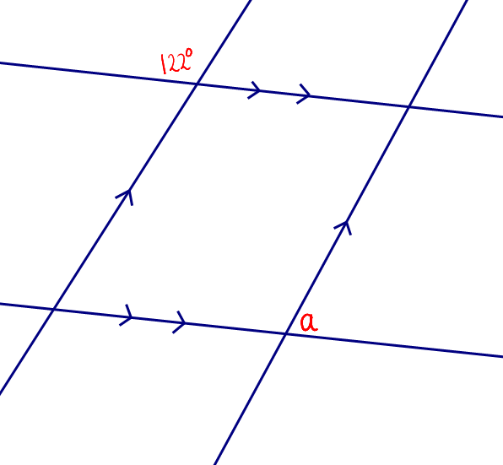

Example 4: Given: $QP∥RS$
RT bisects $∠QRS$
QU bisects $PQR$
Prove: $QU∥RT$

Statement Justification

P 79 8, 10, 14, 16, 18, 20

