2.2.1: Angles Formed by Parallel Lines

Curricular Competencies
A3: I can use tools and technology to explore
B3: I can apply flexible and strategic approaches to problems
C1: I can explain and justify math ideas and decisions
Corresponding angles created by a transversal and parallel lines are equal.
How can you construct parallel lines using a protractor?


To CONSTRUCT parallel lines using a straight edge and a compass:
1. Start with a and a at a place above the line.

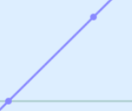
2. Draw a line that goes through the and the .
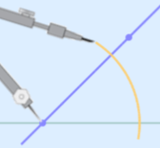
3. Using a draw an from where the two meet. The arc must both .
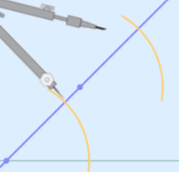
4. Without adjusting the , scribe another from the through the .
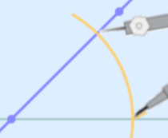
5. From the arc, use the to how far to the line.

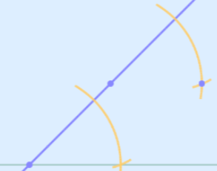
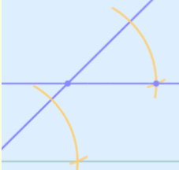
6. Move the compass to the arc and a small arc showing this .

7. Use a to the two points.

Your Turn: Follow the 7 steps above and CONSTRUCT parallel lines of your own.

Measure your lines with a protractor. Are they parallel? Why might they not be parallel?

Recall: Sketch pairs of parallel lines with a transversal and clearly indicate:
Corresponding Angles Interior Angles Exterior Angles Alternate Interior Angles

What do we KNOW about the following angle relationships formed by a transversal and parallel lines?
Corresponding Angles: Alternate Interior Angles:

Interior Angles: Exterior Angles: Alternate Exterior Angles:

We can use deductive reasoning to find missing angles in diagrams.
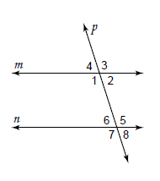
A. Find the measure of angles 2-8 if ∠1 = 115°.
∠2 = _____ because ______________________
∠3 = _____ because ______________________
∠4 = _____ because ______________________
∠5 = _____ because ______________________
∠6 = _____ because ______________________
∠7 = _____ because ______________________
∠8 = _____ because ______________________

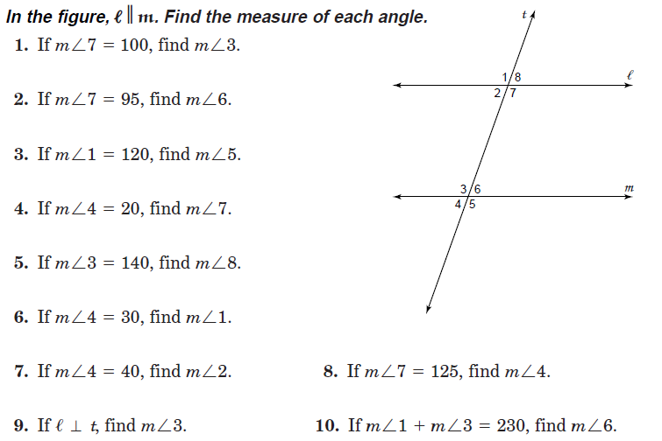
B.

p 78 1-4, Parallel Lines w/s

