2.1.1: Exploring Parallel Lines

Parallel Lines ________
Transversal _______
Label the parallel lines and the transversal on the diagrams below.
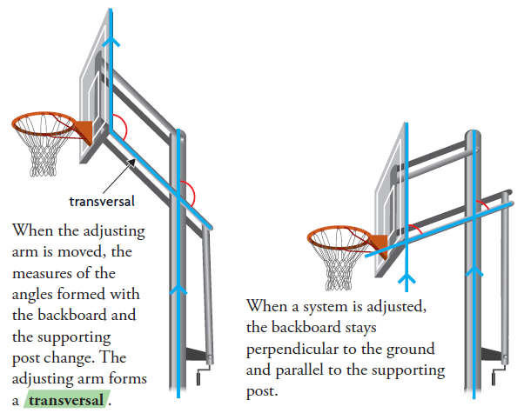
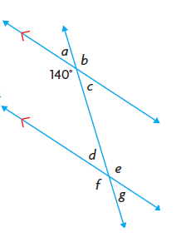
Exploring Angle Relationships

Given the diagram at the right, PREDICT the measures of the angles d through g.

∠a = ______ ∠b = ______

∠c = ______ ∠d = ______

∠e = ______ ∠f = ______

∠g = ______

Interior Angles: __________________________________________________

__________________________________________________

Exterior Angles: __________________________________________________

__________________________________________________

Corresponding Angles: _____________________________________________

________________________________________________________________

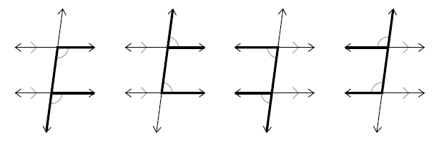
Conjecture: ______________________________________________________

________________________________________________________________

Converse: ________________________________________________________

________________________________________________________________

Write the converse of your conjecture for corresponding angles

________________________________________________________________
________________________________________________________________

Do your conjectures about corresponding angles and parallel lines hold when a transversal intersects a pair of non-parallel lines? Use diagrams to justify your decision.

Alternate Interior Angles: ________________________________________

________________________________________

pg 72 1-2, 4-6

