A sign in the sky

In 1066 a strange sight appeared in the night sky. A monk who saw it wrote this description:
SOURCE 1
Over all England there was seen a sign in the skies such as had never been seen before. Some said it was the star 'comet' which some call the star with hair; and it first appeared on 24 April and it shone all the week.
Anglo-Saxon Chronicle, 1066
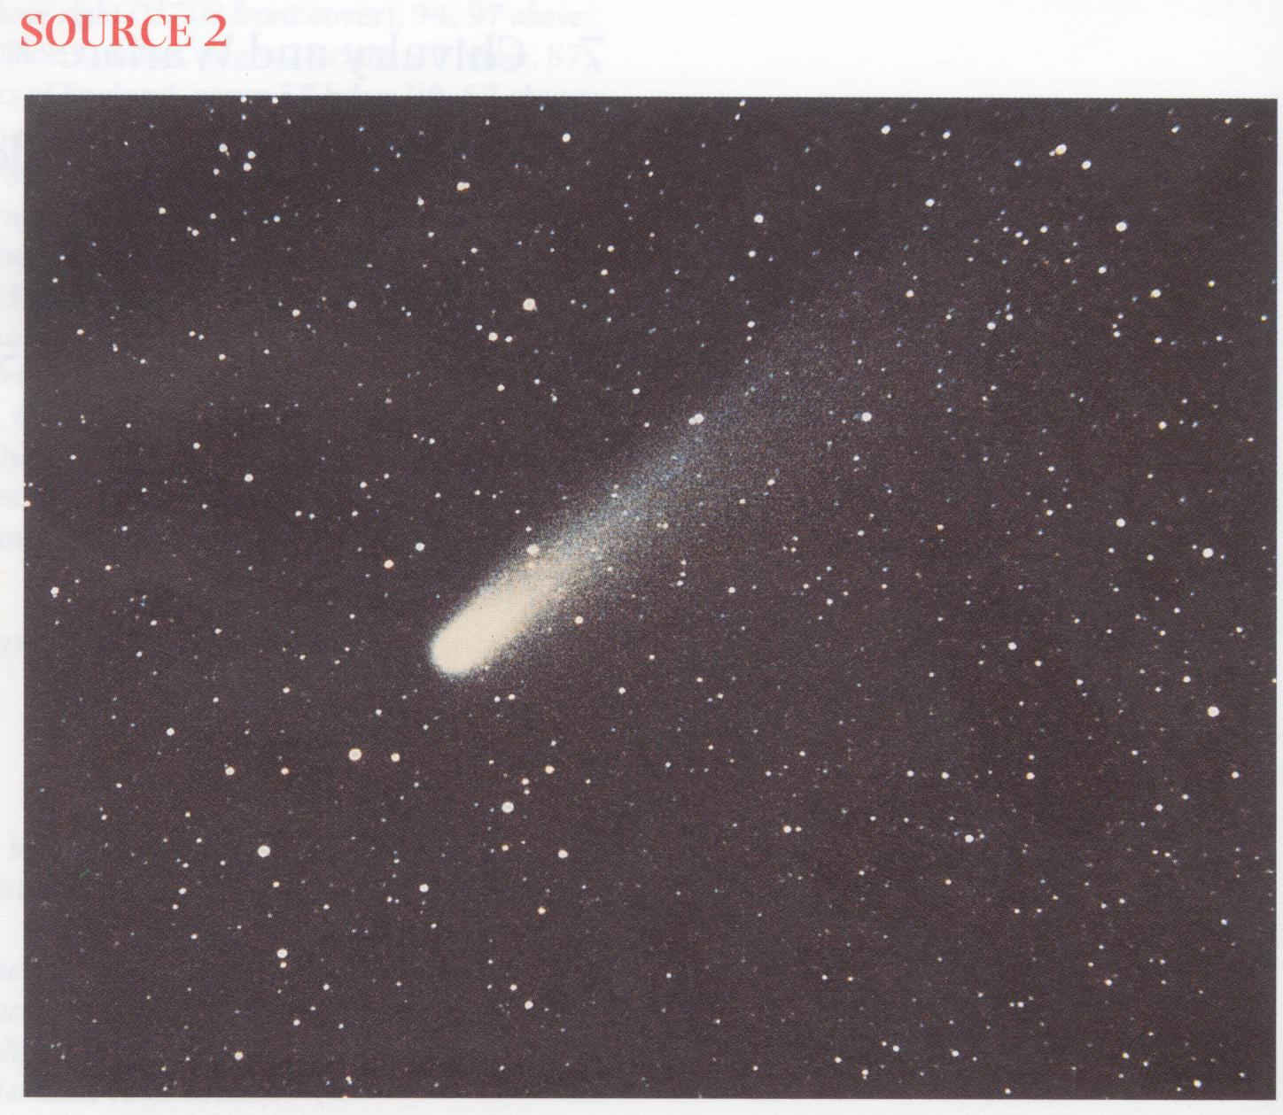
This is what people saw that week. Astronomers call it Halley's Comet. It is a ball of ice and dust that orbits the Sun. When it gets near the Sun it heats up so that gas and dust make a bright ring round its centre and then stream off behind like a tail.

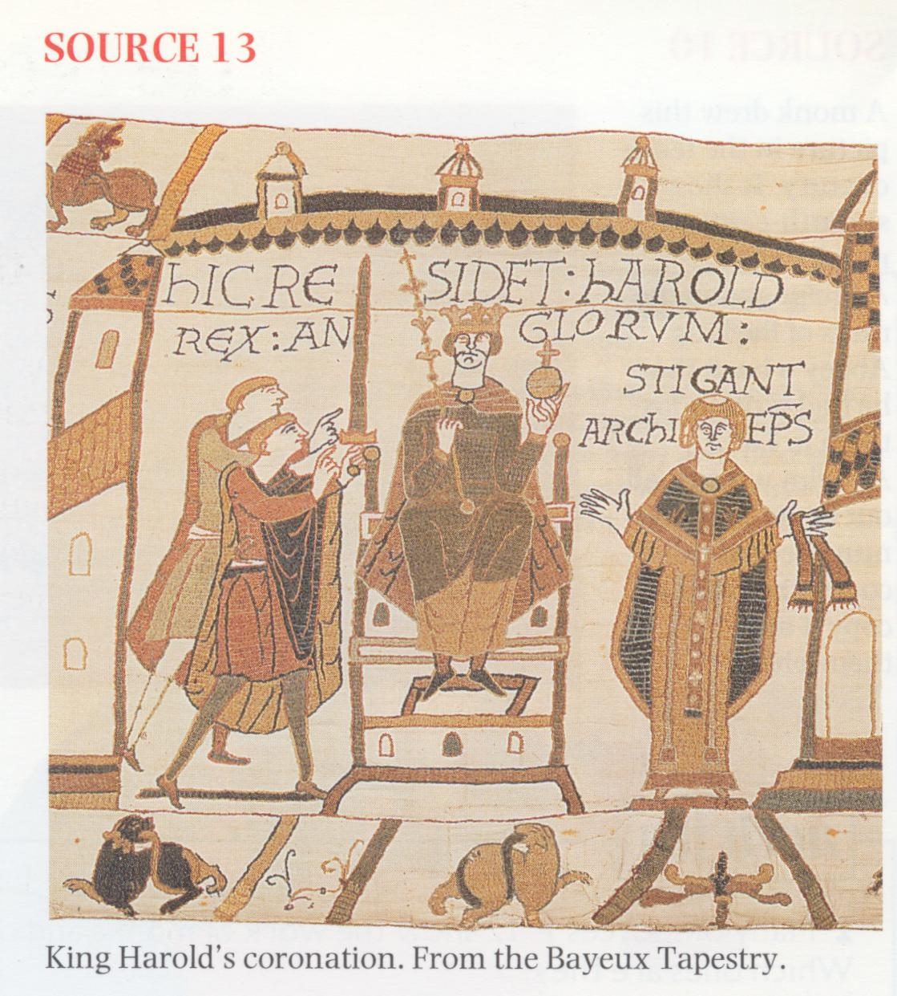
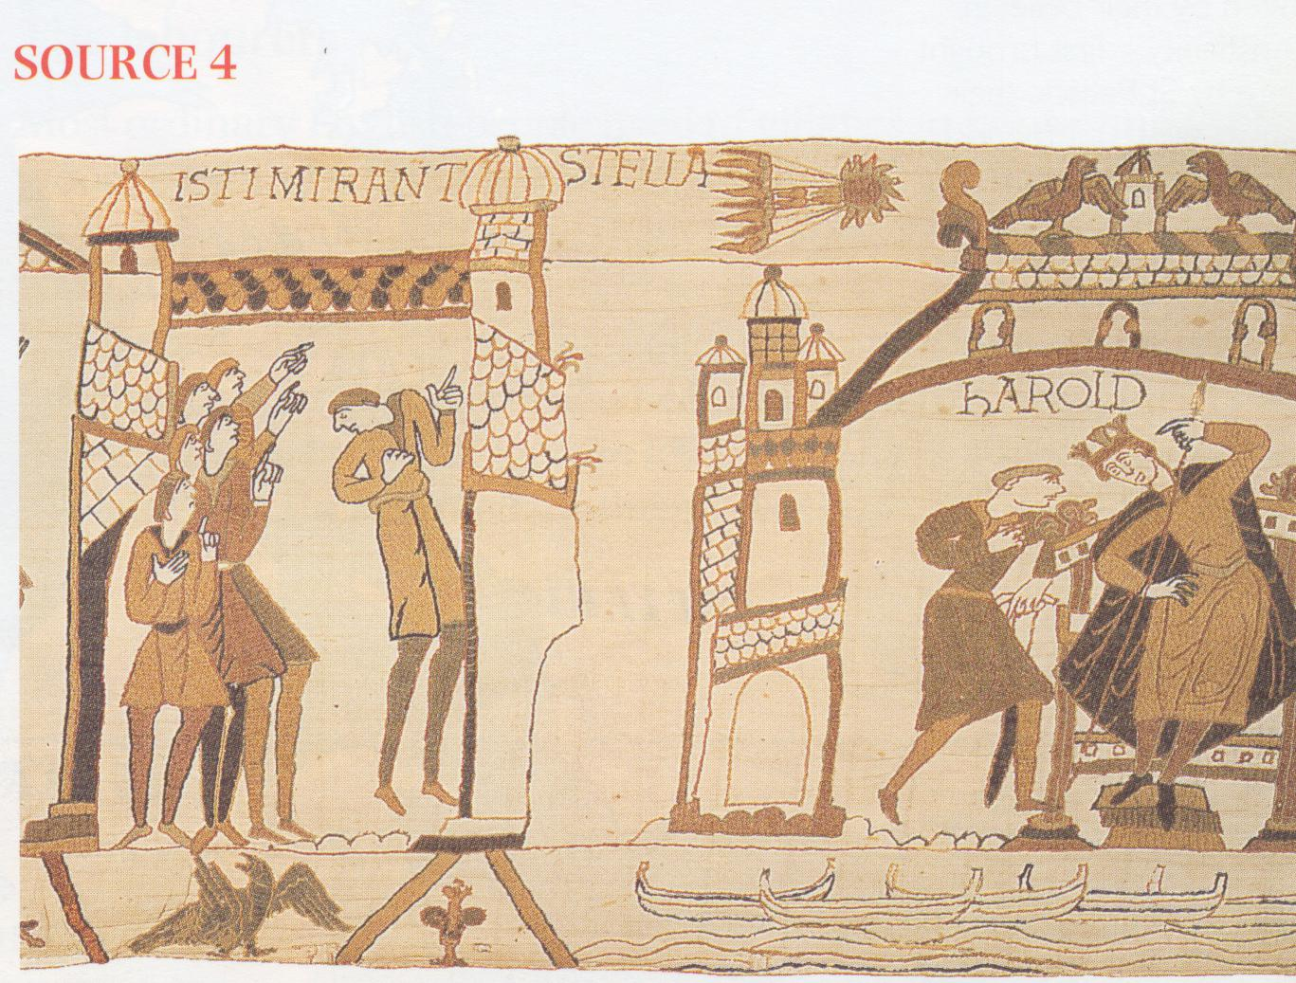

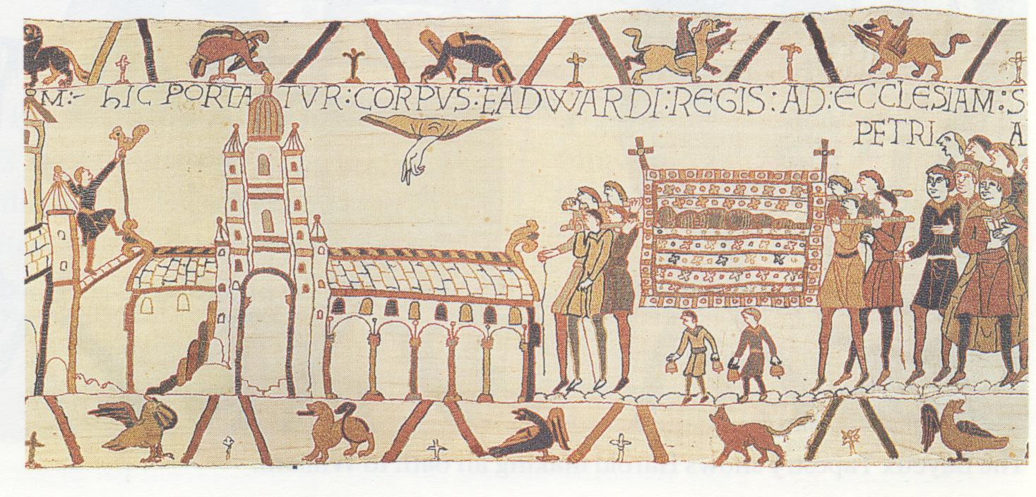
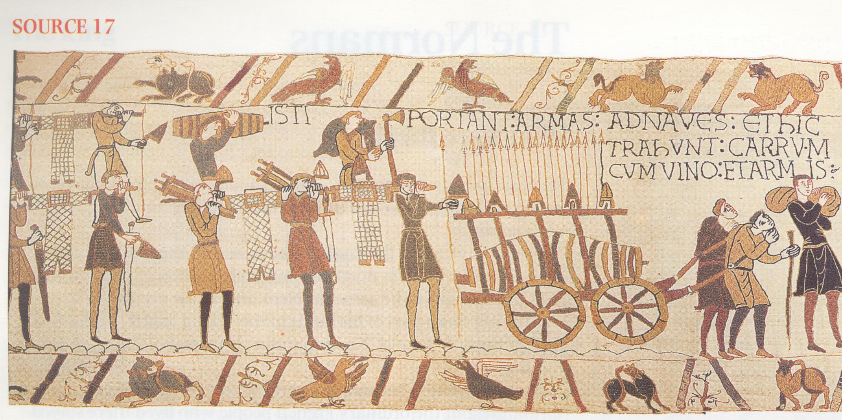
SOURCE 19

SOURCE 20
Edward, king of the English, being without an heir, sent Robert, Archbishop of Canterbury, to the duke with a message appointing the duke as heir to the kingdom which God had entrusted to him.
William of Jumieges, Deeds of the Norman Dukes, 1070
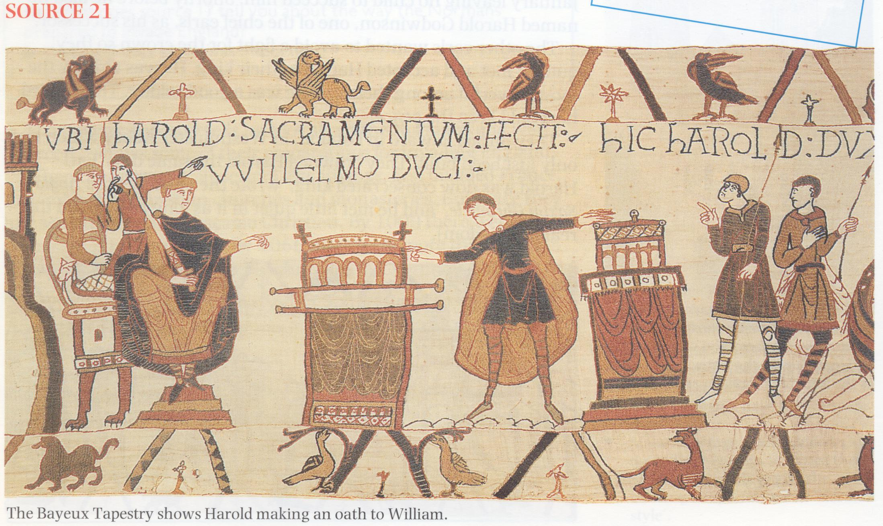

SOURCE 23
William of Poitiers was a Norman. He studied in the French town of Poitiers and then served as a soldier in Normandy. Later he became a priest and was made chaplain to
Duke William. He did not go with the duke on his expedition
to England; but he was in a good
position to find out what happened from those who did.

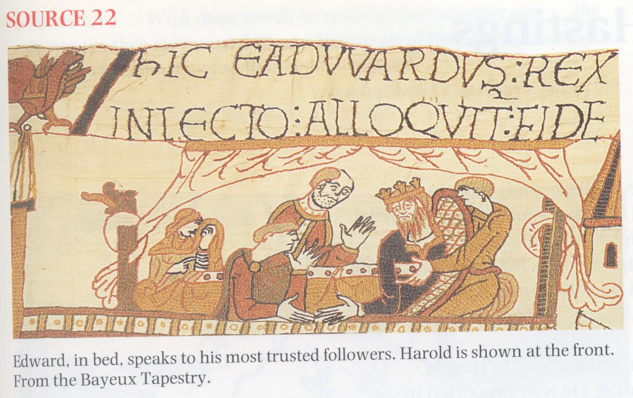
A messenger from Harold is speaking to William just before the battle of Hastings:
`He certainly remembers that King Edward long ago decided that you would be his heir, and that he himself in Normandy gave surety to you concerning that succession. Nevertheless, he knows that this kingdom is his by right, as granted to him by gift of that same king his lord on
his deathbed.'
William of Poitiers, The Deeds of William, Duke of the Normans and King of the English, written
about 1071
SOURCE 24
There came the unwelcome report that the land of England had lost its king, and that Harold had been crowned in his stead. This unfeeling Englishman did not wait for the public choice, but breaking his oath, and with the support of a few discontented friends, he seized the throne of the best of kings on the very day of his funeral, and when all the people were bewailing their loss.
SOURCE 2 5
The next day Edward was buried in kingly style amid the bitter lamentations of all present. After his burial the under-king Harold, son of Godwine, whom the king had nominated as his successor, was chosen king by the chief magnates of all England; and on the same day Harold was crowned with great ceremony.

the victor . . .' With these words he restored their courage and . . . the Normans then surrounded several thousands of their pursuers and rapidly cut them down so that not one escaped.
William of Poitiers, The Deeds of William, 1071

SOURCE 29
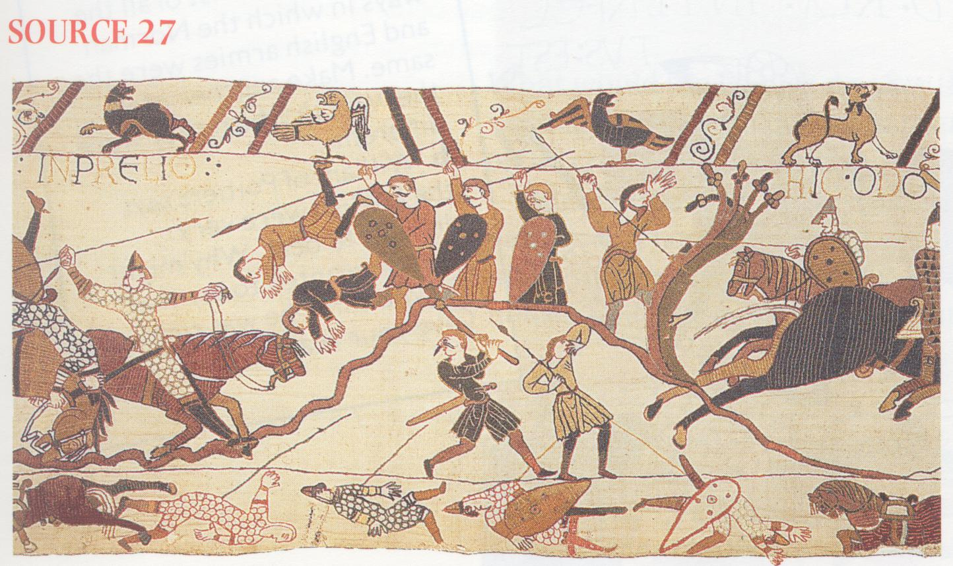
This [English] army was still formidable [strong] and very difficult to overwhelm [defeat]. Indeed this was a battle of a new type: one side vigorously attacking; the other resisting as if rooted to the ground.
At last the English began to weary. Evening was now falling, they knew that their king with two of his brothers and many other great men had been killed. Those who remained were almost exhausted, and they realised that they could expect no more help.
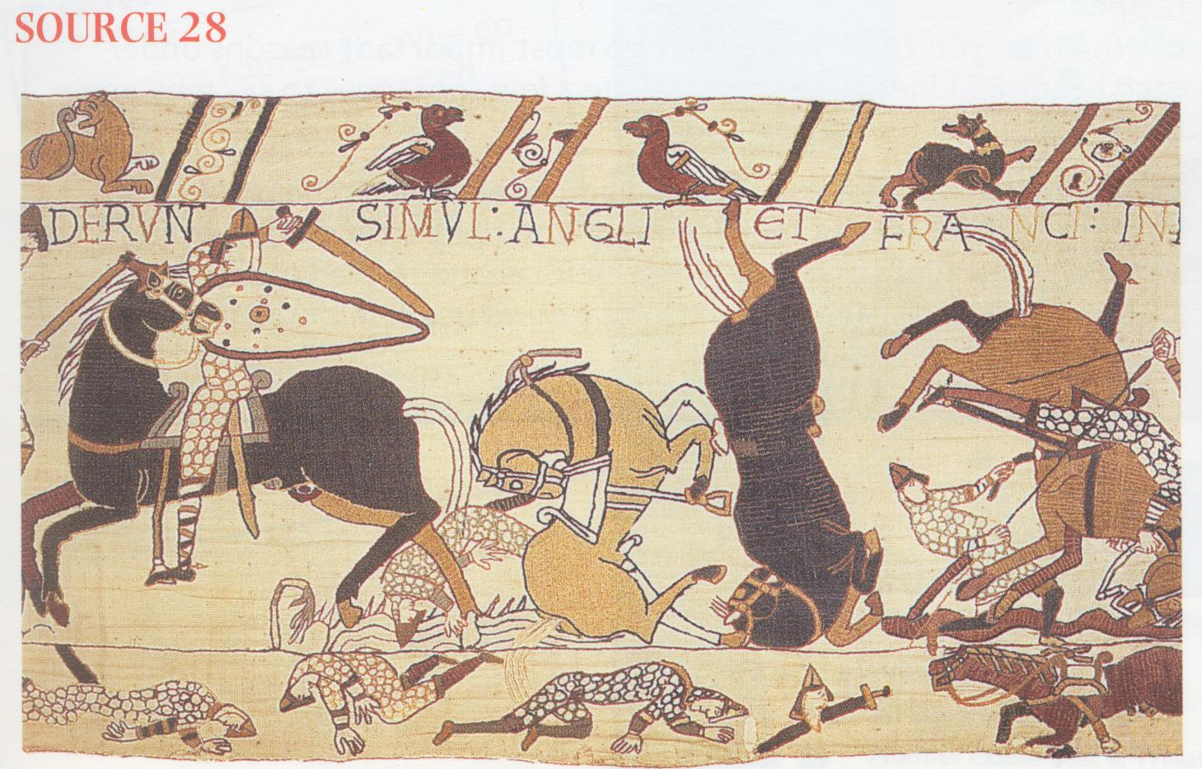
They began to flee as swiftly as they could, some on foot, some along the roads, but most over the trackless country. The Normans eagerly carried on the pursuit, and striking the rebels in the back brought a happy end to this famous victory.
William of Poitiers, The Deeds of William,
1071

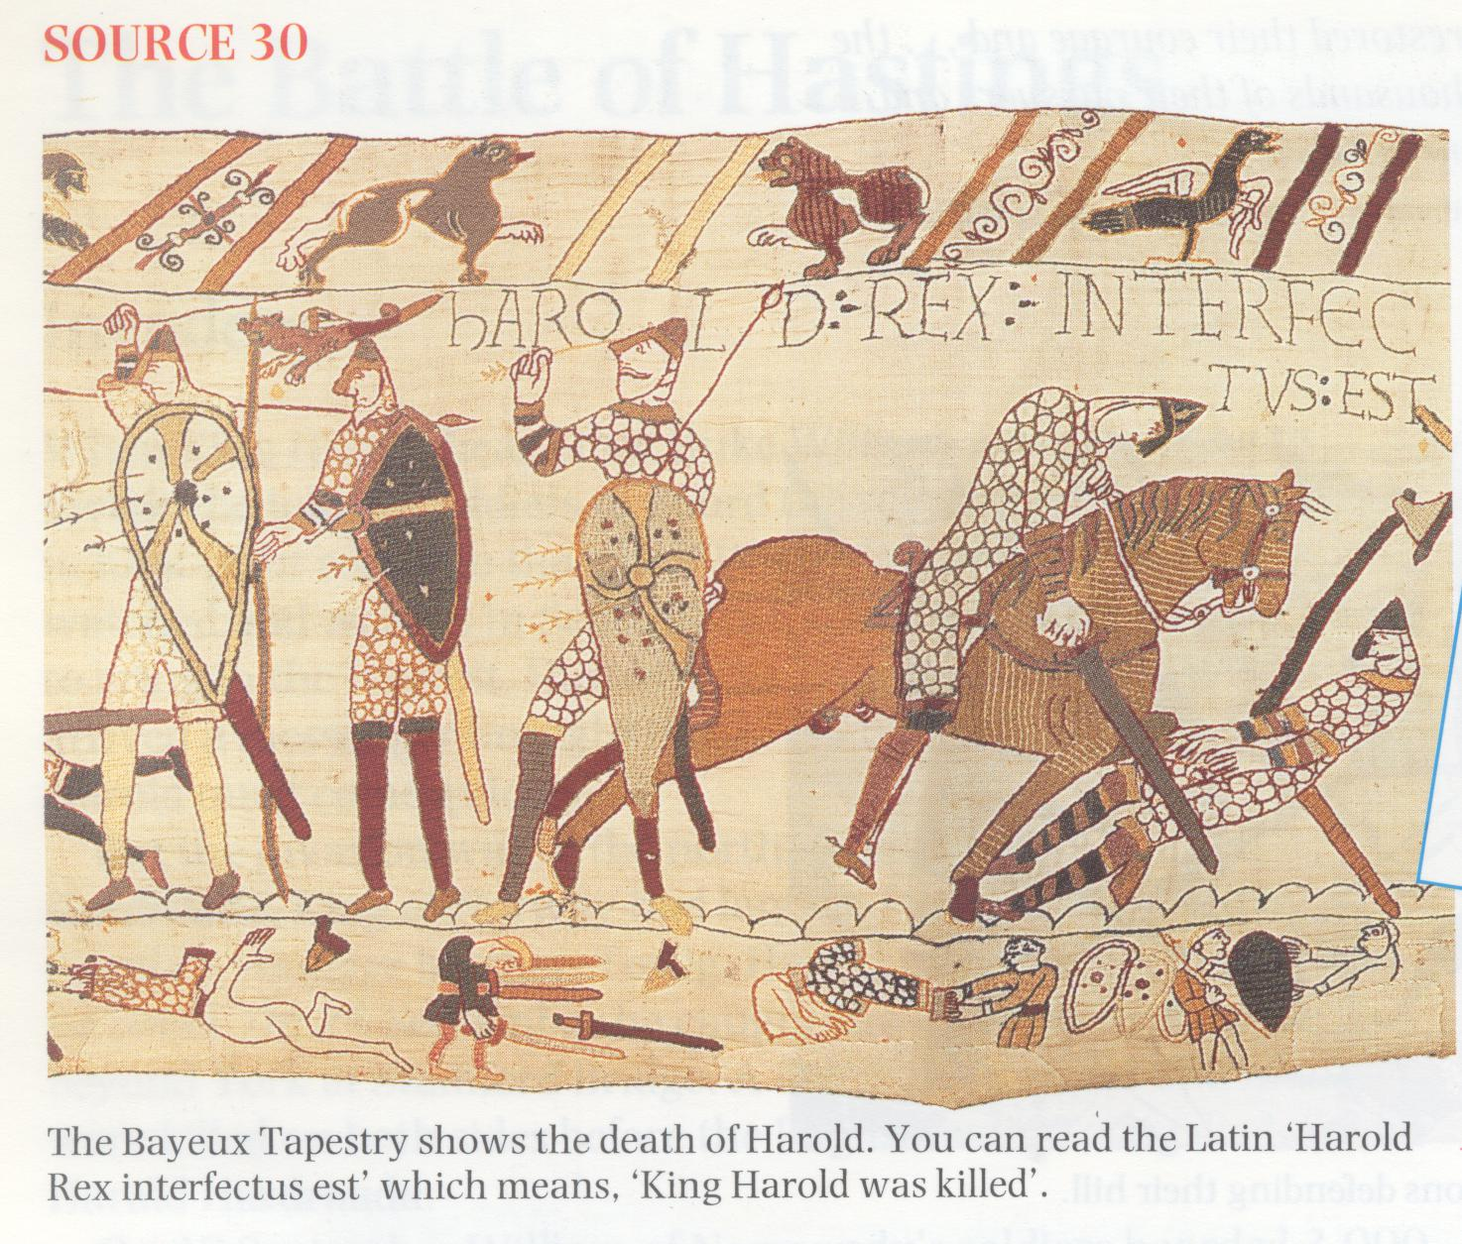

SOURCE 31
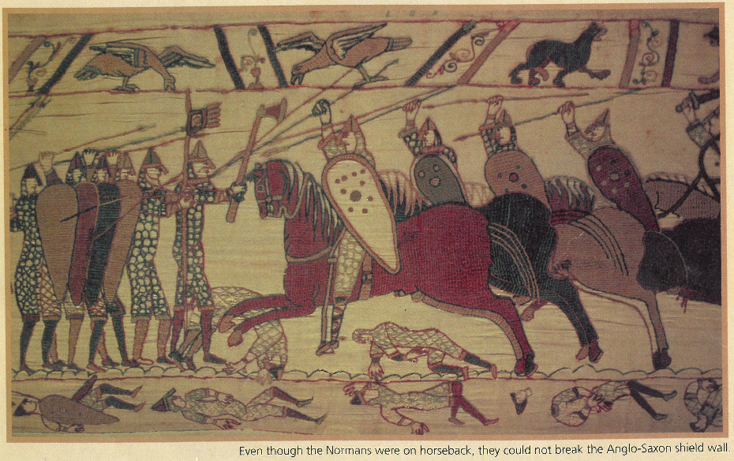

SOURCE 32


