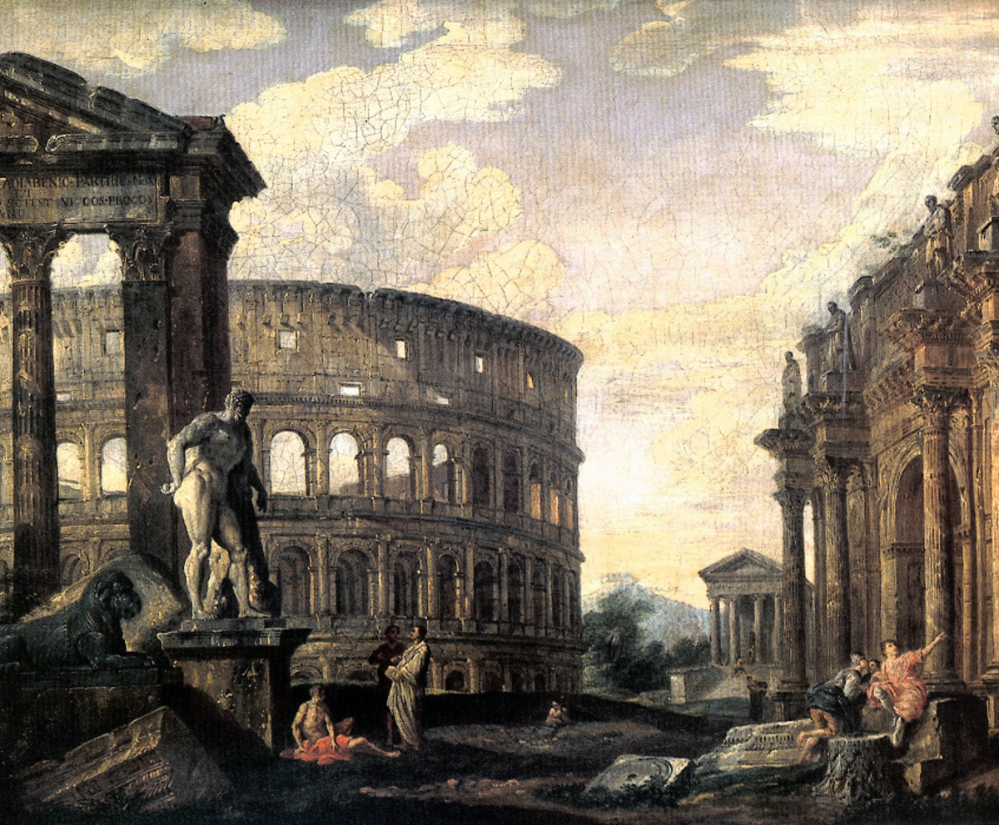 | Social Studies 8  Unit 2 – Middle Ages  Fall of the Roman Empire  Name:

- How did the poor leadership of Rome after 180AD help lead to the decline of the Empire?

- How did Diocletian bring stability and prosperity back to part the Roman Empire? What happened to the other part?

- Why are Germanic tribes invading the Roman Empire?

- How did these invasions of the Empire lead to the beginnings of the feudal system?

- When does Rome fall? Who conquers it?

- What are some reasons for the fall of Rome?

- What is the historical name for the next 600 years in Europe?

- What some of the effects felt across much of Europe when the central government in Rome collapses?

- Fill out the following Chart.
Comparing Systems of Government
Basic Needs of a Gov’t | Roman | German Tribes
Loyalty

Gov’t officials

Taxes

Written Laws/Codes

