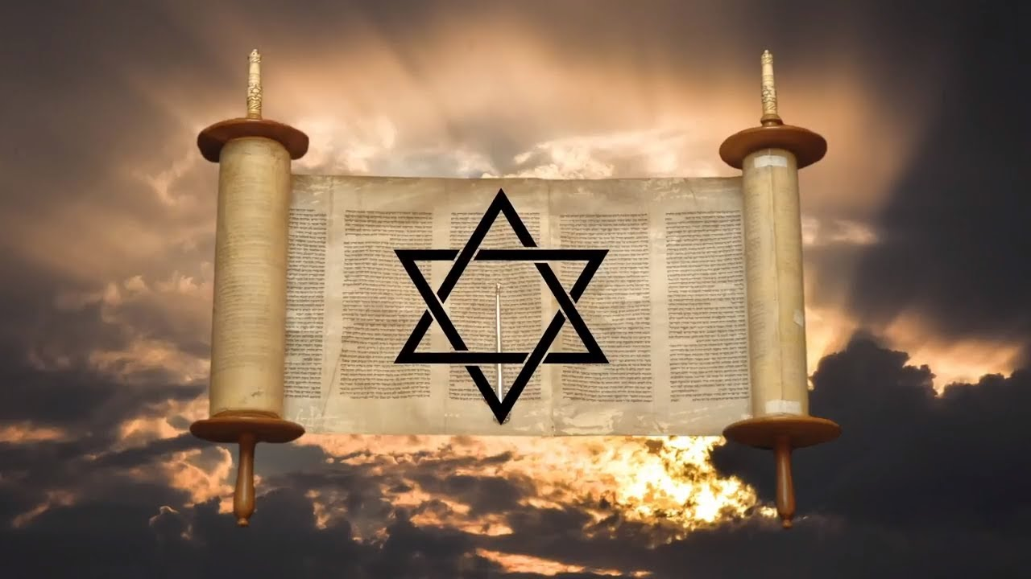 | Social Studies 8  Unit 1 – Civilizations  Religions – Paragraph Assignment  Objective:  Name:
People who have nothing to lose risk everything
People who have something to lose will risk nothing

Here is what the parable was about. Izzy represents the Jews of Israel. She was homeless because of the great Diaspora and she was badly beaten, abused, and many like her were persecuted and killed which peaked during the Holocaust. The parents, Britain and the USA (along with the United Nations) encouraged the Jews to move to Palestine (the attic) throughout the early 20th century. The Palestinians (Pat) had lived there for 2000 years when the Jews (Izzy) began to move in. The parents decided to split Palestine (the attic) in half in 1948.The Palestinians (Pat) who had lived there for 2000 years were moved to half of the land. The Jews (Izzy) were to get the other half. They would name their half Israel. Both the Jews and the Palestinians (who are Muslims) were to share the beautiful closet, Jerusalem. It is a famous city with holy sites for both religions (Islam and Christianity).

War began almost immediately between Palestine, other nearby Muslim nations, and Israel. At the end of the war Israel had more than half the land. Since then fighting has continued. In order to help keep Israel safe the USA has given them large sums of money and advanced weapons, including nuclear missiles. Jews have also moved into other areas that were not originally given to them by the UN. Palestinians have reacted with terrorist attacks. The Israelis have used their very powerful army to destroy most of the Palestinian freedoms especially from a place called the Gaza Strip. For example, Palestinians have to stop at many checkpoints to move between cities (and jobs). They are often denied places to work and live. The Israelis control the fresh water supply (important to everyone, but really important in a desert climate like Israel / Palestine). Palestinians have seen many of their government buildings, records, electrical supplies, roads, access to relief agencies and the like destroyed. Israelis say they are taking these measures to keep themselves safe from terrorism.
Answer the following question in a Paragraph
The Palestinians and Israel do not get along. Why do these two groups not get along with each other and what would be a possible solution to bring peace to their conflict?
- Keep in mind the KEY IDEA: Nothing to lose!! Try to use the key idea that if people have nothing to lose they risk everything / if they have something to lose they fight to protect it.

Break the question down into its components.

Paragraph Planning Chart
Topic Sentence

Detail 1 | Evidence 1 | Explanation 1
Detail 2 | Evidence 2 | Explanation 2
Detail 3 | Evidence 3 | Explanation 3

Concluding Sentence

