So remember that after we look at a religion we’ll look at its strengths. But then to stay focused on bias we’re going to look at an example where a group of people described their actions as linked to their religion and they definitely weren’t following the Golden rule.

Today there are thousands of different types of Christianity. They all believe in Jesus (who said to treat people as you want to be treated). But they have also killed each other because they think one side doesn’t love Jesus the right way. The two largest Christian groups in Ireland are the “Catholics” and the “Protestants”.

England would conquer Ireland in the 12th century C.E. Ireland would become Catholic like England and most of the rest of Europe. In the 16th century, King Henry VIII of England splits with the Catholic Church and creates his own church. He calls his church the Church of England. Members of the Church of England are known as “Protestants”. Why?

In the 16th and 17th centuries, England would try to force their church on the Catholics of Ireland. The Catholics would continually resist. This resulted in brutal treatment of Catholics in Ireland they would be discriminated against for centuries. Most of the land, political positions, and good paying jobs would be held by Protestants. They became a ruling class. Most Catholics were poor tenant farmers. The laws were harsh and meant to persecute them because of their religion.

In the late 1800s and early 1900s, the Irish Catholics wanted to regain their rights demanded to split their country away from England. Most of the Protestants live in the northern part of Ireland who were bitterly opposed to leaving English rule. In 1920 Ireland would be split into Northern and Southern Ireland. Each would get their own limited government. By 1948, Southern Ireland completely broke away from England and became its own country (the Republic of Ireland). Northern Ireland remained a colony of England. Catholic discrimination in Northern Ireland continued: separate schools, separate neighbourhoods, voting restrictions, and higher unemployment due to discriminatory hiring practices.

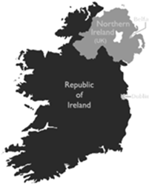
In Northern Ireland (lighter grey part of the map to the left) 45% of the population was
Catholic. The people in power were the Protestants (at 55%). By 1969 violence would erupt in Northern Ireland as the Catholics try to gain better conditions for themselves. Both groups used terrorism to try to destroy the others. This time was called “The Troubles”.
Some of the terrorist activities included bombings, assassinations, shooting of children as
punishment to adults, kneecapping (physically being shot in the knee is very painful, stops you from being able to walk so you warn others, but if you’re caught kneecapping you don’t spend as much time in jail as you would for murder), arson, and robbery.
Terrorism isn’t just powerful for the acts of violence. It causes people to be afraid all of the time. Socially, during The Troubles, people were constantly traumatized. Activities were limited, with pubs and cinemas closed.
To go shopping in the city center required passing through military security gates and being subjected to body searches (at any age). Young people, often bored, reverted to vandalism. Older people, also bored and scared, had extramarital affairs, leading to many divorces and illegitimate births. Alcoholism and suicide rates were very high.
After hundreds of years, it was hard to try to stop the hatred. From 1969 onward, 3720 people were killed as a result of the conflict. Northern Ireland became poor as businesses, factories, and tourists were scared away. But in 1988 a peace plan was started. They began to realize if they had peace, companies would start to build factories and stores, and everyone would become more prosperous. A peace plan was put into place in 1998. The unemployment rates lowered, and tourists returned. The wealthier people became, the better their standard of living became, the more invested they became in peace.

What was one of the root causes of the long history of violence in Ireland? Explain.

Based on what you have learned about Christianity, what would you expect to the conduct of both sides in this conflict? Explain. Give examples.

According to the article, what is the power of terrorism when there is no violence?



When people have something to lose they will risk nothing to keep it.
When they have nothing to lose they will risk everything.

During The Troubles, people had nothing to lose, so they would risk everything (like
bombing, terrorism, adultery, etc.). How were they finally given something to lose?

Charts & Graphs / Primary & Secondary Resources
Answer the following questions using the graphs and charts below.

Using the line graph, how many full decades does the graph represent?

What decade was the worst for deaths in Northern Ireland?

Can you tell exactly how many people died in 1972 from the graph? Why or why not?

Approximately how many people were killed in 1972?

Now, look at the chart and bar graph. Both have the same information.

Which one do you find is faster and easier to read? Why?

What is an advantage of the bar graph over the chart?

What is an advantage of the chart over the bar graph?

Think about the time frame of The Troubles. What do you find remarkable about many of the statistics of this conflict.

How were more people than just those involved in the direct conflict impacted by The Troubles?

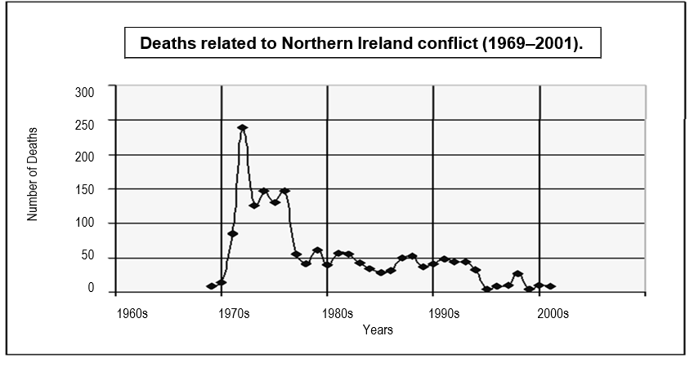
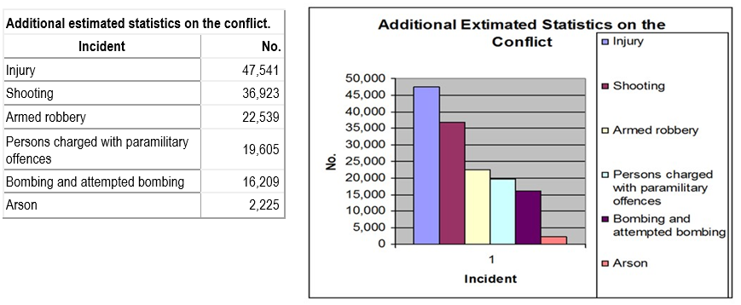
Additional Estimated Statistics on the

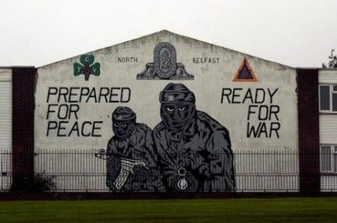 | The picture on the left is from what city?  How, based on what you’ve learned about the teachings of Jesus, is the message correct for Christianity?  Now, how is it really, really, really wrong?

Read the following:
My mood was just total black despair. We seemed to be entering some sort of apocalyptic world where your worst nightmares ran for twenty-four hours a day. You couldn’t go on a bus or a train for wondering if either it or the station would be blown up. You couldn’t walk down a street where cars were parked for wondering if one of them contained a bomb. You couldn’t leave your car on to be fixed because when you went back to collect it the workshop was probably now a hole in the ground. Every day some landmark that you loved or a favourite store was bombed or burnt. I remember coming into Belfast one afternoon and finding the giant Co-Op store blazing from end to end. That was the final straw. I put my head in my hands and found tears running down my cheeks.” Jeffrey Glenn

Is this a primary or secondary source? Explain how you know?

Why do you think a burning grocery story causes Jeffery to cry?

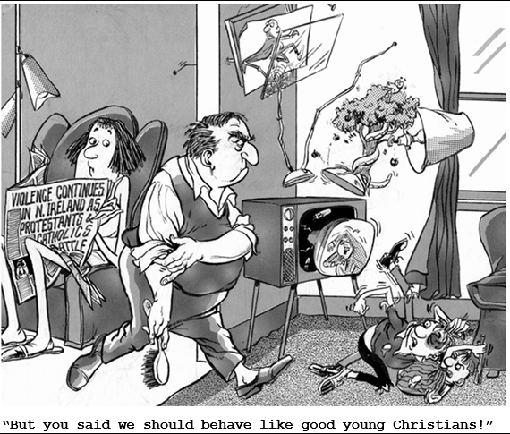 | Answer the following questions based on the cartoon to the left.  What is the title of the newspaper article the mom is holding?  How are the children behaving?  Why do you think they believe they are behaving like “good young Christians”?

