Islam/Regilions/Bias Name:
All religions say to treat everyone as you want to be treated (the Golden Rule). But humans take over and many times cause harm. Here is an example of some Muslims who have chosen concerning behaviors in the name of their religion
Muhammad Cartoons Controversy  In 2005 Danish newspaper Jullands-Posten began 12 editorial cartoons, most of which depicted the Islamic prophet Muhammad.  Danish Muslims organized protests.  The cartoons were then published in 50 other countries, deepening the controversy. This led to protests across the Muslim world, some of which escalated into violence with police firing on the crowds (resulting in more than 100 deaths, altogether).  "We are seeing a clash of two different notions of what is sacred" Karen Armstrong, religious affairs commentator  Charlie Hebdo, a French magazine, continued to draw Muhammad. They were taken to court for inciting hatred & were found not guilty. In January 2015 two masked gunmen went into their offices & killed 12 people, wounding 11.  In Denmark there are calls to put the prophet Muhammad cartoons in text books | Salman Rushdie and the Satanic Verses Controversy  February 14, 1989 a death sentence against Islamic British author Salman Rushdie was proclaimed by the religious/government leader of Iran. It required Rushdie’s execution because in his 4th novel he added verses to the Qur’an.  The book sparked violence around the world, with bookstores being firebombed and book-burning rallies. Some people in possession of the book were seriously attacked and some killed.  Rushdie was forced to live under police protection for years.  Rushdie has reported that he still receives a “sort of  Valentine’s card” from Iran each February 14th to remind him they have vowed to have him killed (Even though they officially withdrew their threat in 1998)..  In 2007 Rushdie was knighted by Queen Elizabeth II. Muslims around the globe, again, protested.

From what you have learned about Islam, why would many Muslims be upset with cartoons of Mohammad?

From what you have learned about Islam, why would may Muslims be upset with Salman Rushdie?

According to Islam, which of the responses to these two incidents would be acceptable? Which responses would not be acceptable? Explain.

What do you think about the no putting the cartoons in a text book? Should it be done? Yes or No? Explain.

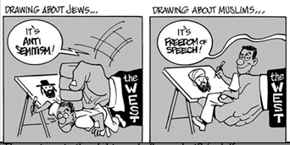
What is the bias in this cartoon?

Based on our discussions, why do you think this bias exists in western media?

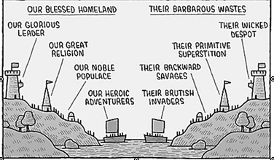
There are some great comparison words for bias in the cartoon above.
What are some of the positive words used above?

What are some of the negative words used for their enemies?

How does a cartoon like this relate to the Shia and Sunni conflict?

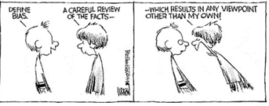
Does this cartoon represent a good definition of bias? Explain.

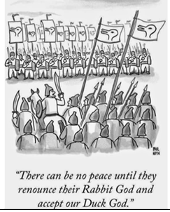
Using what you have learned, write a paragraph to discuss how the modern religions we have studied are reflected in this cartoon. Explain with examples from your notes and our discusioins.

