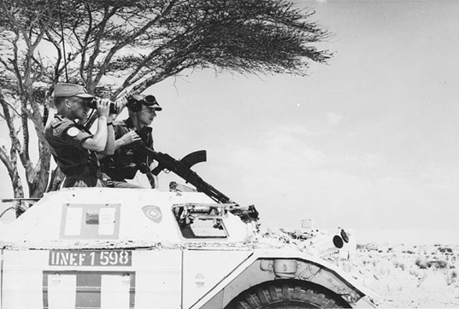 | Social Studies 11: Independent Foreign Policy  Suez Crisis and Cuban Missile Crisis  Name: ______________________________  Date: _______________________________

Complete the following questions - Read pgs 260-261 Spotlight Canada and 139-142 Counterpoints
1. Why did Britain and France land troops in Egypt?
2. How did the Suez Crisis divide public opinion in Canada?
3. Explain how Lester Pearson gained recognition in the Suez Crisis.
4. Where would troops for the UNEF come from? What were the duties of the UNEF?
5. Describe relations between Canada and the U.S. during the 1960s.
6. a. How did Prime Minister Diefenbaker upset the Americans during the Cuban Missile Crisis?
b. What was Diefenbaker's reasoning for his actions?

